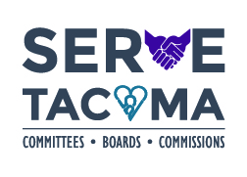
FOR IMMEDIATE RELEASE
January 3, 2019
MEDIA CONTACT
Andreta Armstrong, Staff Liaison, aarmstrong@cityoftacoma.org, (253) 591-5849
Applicants sought for the Human Rights Commission
The Tacoma City Council is looking to fill seven positions on the Human Rights Commission.

The Human Rights Commission consists of fifteen members serving three year terms and is composed of representatives of the general public and the employer, labor, religious, racial, ethnic, handicapped, and women's groups in the city.

The Commission brings the perspectives of the rich diversity within our community from a variety of backgrounds including, but not limited to, persons with disabilities, youth, labor, religious, racial, ethnic, LGBTQ, gender and gender identity groups in the city.

To find out additional information on the Human Rights Commission, please visit their website or contact Andreta Armstrong at (253) 591-5849.

Applications must be submitted to the City Clerk’s Office by Thursday, January 17, 2019.
To apply, please visit www.cityoftacoma.org/cbcapplication or contact Jessica Jenkins at
(253) 591-5178, servetacoma@cityoftacoma.org, or in the City Clerk’s Office, Room 11,
Tacoma Municipal Building North, 733 Market St., Tacoma, WA 98402.

###

