Business Office
813 S. 13th St.
Tacoma WA 98405
PHONE -253-302-3347
FAX – 253-301-1904
Recoveryfoundationusa.com

OFFICE HOURS:
Mon -Thurs 10am to 4pm
Friday by appointment only
Sat and Sun closed
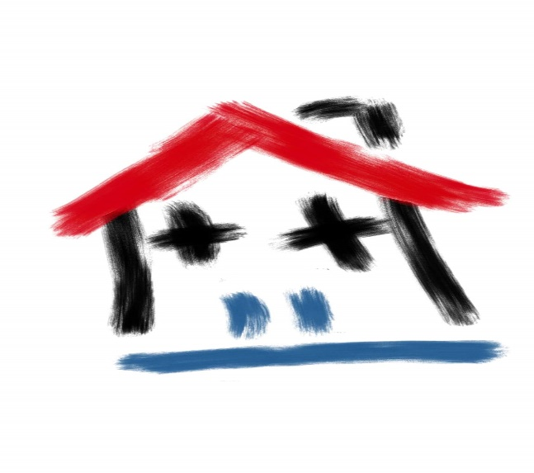
PROVIDED IN EACH HOME

- Fully Furnished
- All utilities included
- Cable, Phone and WIFI
- Washer and dryer in each unit
- 24 onsite managers available
- Supportive services and Navigation of community resources.

Monthly Rates
Shared Room: $500.00 per month
Single room: $600.00 per month
ONE-TIME NON-REFUNDABLE PROCESSING FEE: $150.00

Our Mission
To provide a clean, safe and sober environment to all in need of quality housing.

