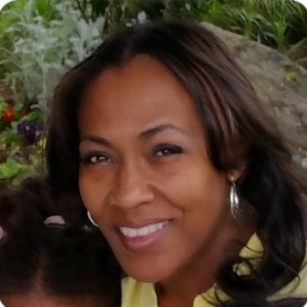  Bridgette Johnson, MSW, LSWAIC, CdP  Founder of BIMA (Believing In Myself), Services. I was once detached from my purpose, homelessness and struggled with emptiness, searching for something I thought I could never find. Someone once told me that change is an inside job that manifests itself outwardly. I BELIVED IT! As a direct result of my experience “BIMA” was birthed. It is my core belief and experience that change is possible if you only believe.  BIMA Services wants to help you to Believe Again.  BIMA shared housing services offers individuals and opportunity to be HERD.  Be HOMED  Be EDUCATED  Be RESTORED  Be DETERMINED  We offer housing through shared living experience which includes supportive case management services and connections to community resources. It’s not just housing, It a restoration program for long term stability.  REQUIREMENTS  - Must be 25 older  - Pass basic screening criteria  - BIMA case management involvement  - Working towards independent living  - Community Outreach Particpation |  | Contact:  Bridgette Johnson  Bridgette@BimaServices.org  206-393-2273 |  | 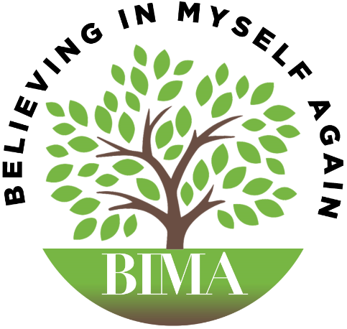  - TReat a person as they are, they will remain as they are. Treat a person as they can be and they will become as they can and should be.”  Stephen R. Covey
 |  | Bridgette has been a champion for individuals for many years. She views BIMA with passion and determination and hopes to send MORE champions into the community.
Focus: Women who can use BIMA as a

Programs: Offered
Staff: BIMA staff have excellent reputations s of the
BB
B.I.M.A (Believing In Myself Again)
A Restoration program, providing a one-stop approach to support services, case management, counseling and housing.

Mission: Reposition individuals who have lost faith in themselves, house them, educate them, restore them, and evoke determination in that individual to positively influence their community
Vision: BIMA to become the leader in long-term, full service self-sustainability programs
Goal: Provide a three-phase program that will allow individuals to reach restoration, stability and economic independence through their journey towards self-efficacy by being the first and last place someone has to come for help.
Objective: focus on the needs of the homeless and recovery community by addressing both internal and external barriers that prevent a lifestyle of restoration.

SERVICES OFFERED
Shared Housing
Case management/support services
Substance use assessment
Community referral
Counseling services
Employment coaching
Educational coaching and support
Life skills
Financial budget coach

COMMUNITY OUTREACH
Weekly, BIMA partners with HOPES International and A local church to feed the homeless community, right on the corner of 12th and Altheimer.
Each house member will participate in BIMA’s community outreach program.

FUTURE SERVICES
Parenting Classes
Health Coaching
BIMA Gardens Apartments

