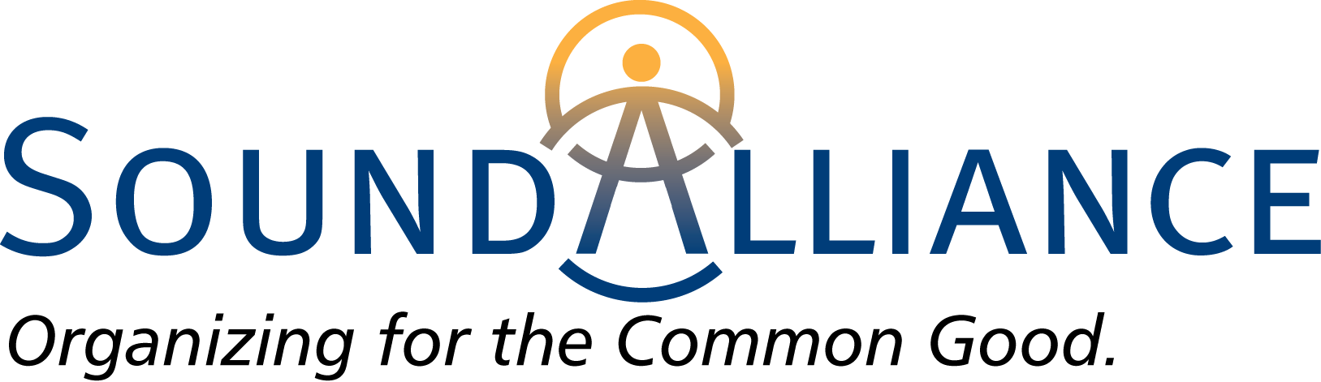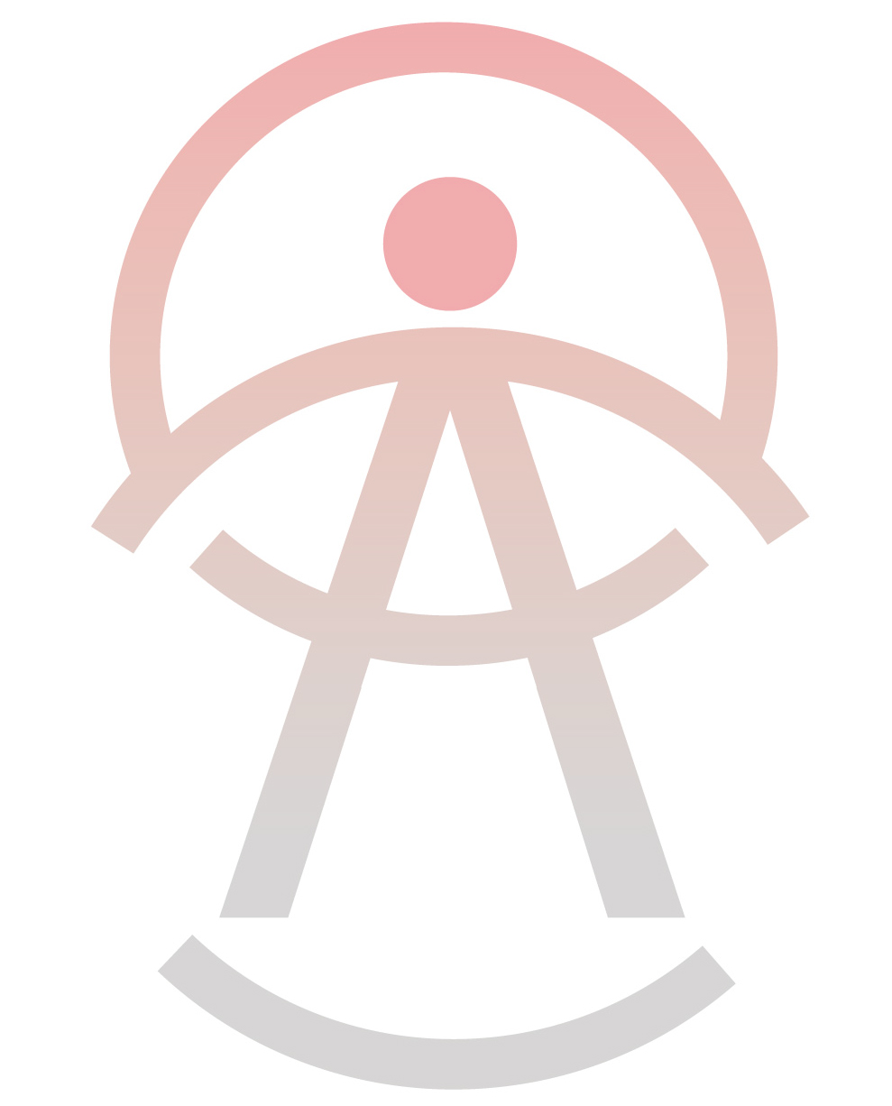

Independent · Nonpartisan · Nonprofit

**Soundorganizing.org · facebook.com/SoundOrganizing · info@soundorganizing.org  
425-390-4418 · 649 Strander Boulevard, Suite B, Tukwila, WA 98188**

**leadership institute**Friday, November 15th, 7:00 – 9:00 PM

Saturday, November 16th, 9:30 AM – 4:30 PM  
*We start and end on time!*

Eastside Family Support Center, 3569 E. Roosevelt Ave., Tacoma, WA

The Sound Alliance, in King and Pierce Counties, is made up of faith, labor, and community organizations dedicated to building a base of every day citizen leaders to effectively stand for change they want to see in their communities.

Join us for this 9-hour training to learn our organizing model and to be a part of our work for the common good!

The Institute provides content based on the philosophy and practices developed by the Industrial Areas Foundation (IAF) in 80 years of organizing experience. The topics include:

* **Why Organize? –** Examine the history, traditions, and values of our labor, faith, community and educational organizations.
* **Fundamental Organizing Skills –** Learn tools to conduct individual relational meetings, listening sessions, research, negotiations and action to help obtain a concrete, winnable outcome.
* **Strengthening Our Institutions -** Engage people systematically in a culture that is relational, action-oriented and reflective.
* **Problem vs. Issues –** Focus from general problems to concrete, winnable issues by using relational power in the public arena to negotiate for the common good.

**Cost**

* Participants from Sound Alliance member organizations: FREE
* Participants NOT from Sound Alliance member organizations: $50.00 (can be applied to future organizational membership dues)
* Lunch will be provided on Saturday. We are asking for a $10 donation to offset costs.
* Free parking

**Registration**

Go to the Sound Alliance web page, look for events and register on the Google form linked there.

For further information, email [dorothy@soundorganizing.org](mailto:dorothy@soundorganizing.org)

Registration deadline: Tuesday, November 12, 2019