Weekly COVID-19 Housing & Homelessness Call
Wednesday, June 10th, 10-11:15am via Zoom
Time | Topic | Lead | Notes:
10:00  5 min  Teresa | Welcome & Settle in | Rachael Myers, Housing Alliance | - The purpose of these calls is (1) to share information about what’s working in communities and what gaps still exist in terms of keeping people housed & safe during COVID, (2) to provide updates about what the state is doing to help, and (3) to make sure both the Housing Alliance and our state leaders hear about what’s helping and what needs still exist. These calls help inform our advocacy. Thank you for being here.  - Also want to acknowledge the uprising we are seeing, calling for changes in police system and affirming Black Lives Matter. Housing Alliance believes that too, and we are recommitting ourselves to supporting that work.  - This Friday there is a call from Black Lives Matter Seattle King County chapter to gather for a march. We assume there are actions being organized in other parts of the state, and encourage people to participate.  - Q: What is our position on the movement to #defundthepolice?  A: We haven’t had a robust internal conversation about what that means, but have shared actions and signed onto a letter to defund SPD. When people say defund the police, it means a lot of things. What it doesn’t mean is defunding solutions that keep our communities safer. What we believe is there are better ways to keep communities safe than militzarized police departments. It’s very likely with the economic impact of COVID, there will be state and local cuts. Improtatnt not to cut programs that really keep our comm safe, like housing. Asking our comm to move resources to those solutions. We’ve seen very clearly in the past few weeks that police don’t always keep all members of our comm safe.  - More in the coming weeks. We’re thinking of doing a webinar about what it would mean to divest from police and invest in comm orgs that meet ppls’ needs.  - Links: https://blacklivesseattle.org/statewide-silent-march-and-general-strike-on-friday-june-12th/  - National Innovation Service blog on defunding the police: https://www.nis.us/blog/how-to-defund-your-police-department-in-six-steps
10:05  5 min  Emily/ Caroline | Poll Questions |  | - Where are you joining from today?  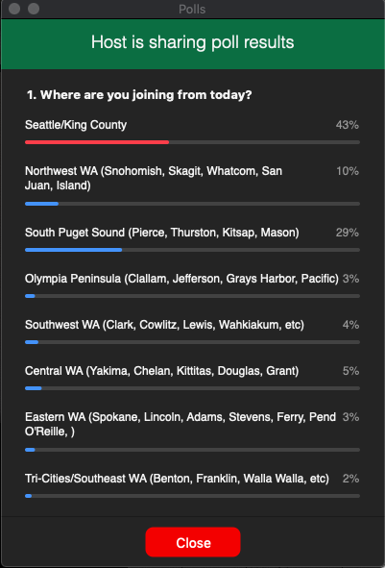  - In WA, the top 1% of income earners pay what % of their earnings in taxes each year?  - The lowest quintile of people roughly pay what % of their income in taxes annually? (People who earn less than $21k)  - 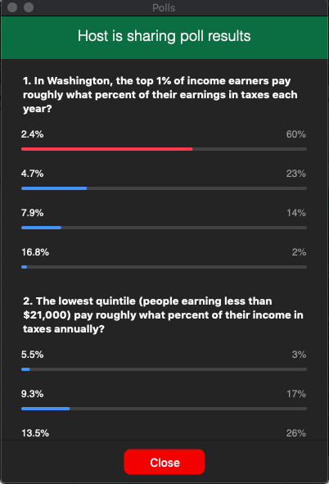  - 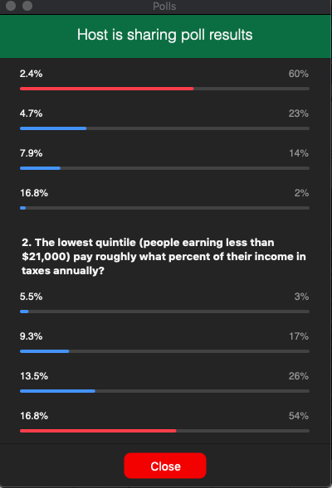  - According to the Latino Civic Alliance “Protect Agricultural Worker’s Q&A, all of the following are true except... Latinos make up 90% of Agricultural workers in the state.  - 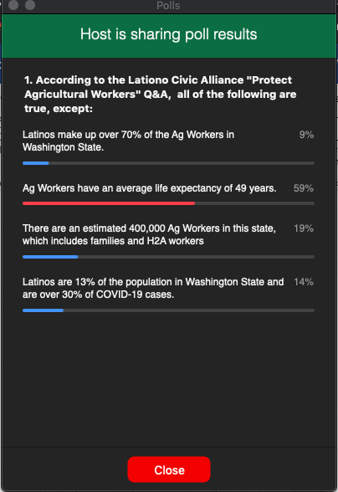
10:10  10 min  Emily | Updates from the Department of Commerce | Tedd Kelleher, Dept. of Commerce | - Big news is that emergency solutions grant gave an initial tranche grant, good news that WA state does really well on these formulas, we got an additional 46mil dollars  - Not with ESG, traditional HUD grant, used to be emergency solutions grant, but changed the acronym  - First tranche of funding is on its way  - The 2nd tranche will require more work, but working on it  - ^ Not on commerce’s website, can send a spreadsheet from HUD’s website. (see below link)  - Seattle/KC is getting roughly 30 or 40 million dollars directly  - Diane: the total amt for WA is 115 mil, seattle: 29.3... see link for details: https://www.hud.gov/program_offices/comm_planning/budget/fy20/  - Q: 1) will you just add the second tranche as an amendment to the contracts you will send out this week? 2) do you have any idea when the second tranche will be available?  - A: Don’t know if we have enough information, still getting guidance from HUD, some scenario where we’d put it out separately, but feels unlikely  - Q: Any info on the next steps/timeline for the Commerce Draft Shelter Grant that we submitted comments on last week?  - A: Racing through comments, most comments we’ve ever received. Multiple hour-long meetings. Still out intention that this $ will be out in the summer. Don’t see any roadblock to getting it out this summer
10:20  10 min  Teresa | The importance of fighting for progressive revenue in Washington | Sen. Joe Nguyen, 34th Legislative District | - Very committed to making sure we don’t have an austerity budget next session.  - Our state has an estimated $7-8B budget shortfall over next 3 years. We’ll have a better idea once the new revenue forecast comes out, but it will probably be worse than that. Even if we use entire budget stabilization account, it’s still looking pretty bad.  - We can cut, we can raise revenue, or we can do both. In the great recession of 2008, the state only enacted budget cuts.  - 85% of our state budget is constrained: half constitutionally constrained, the rest constrained by the federal government. So there’s a relatively small part of the budget where we can make cuts: affordable housing, higher ed, things like that.  - Sen Nguyen was a bit shocked to see so many Democrats advocating for cuts. Pushing back against that narrative will be important. To get back to stable economy, we need consumer demand. TANF, housing, and programs like that are how we keep people stable, and the only way to get back to a stable economy.  - Earlier on the call folks called out was regressive nature of our tax system. In 2008, the legislature didn’t increase revenue (on those who could most afford to pay their fair share), but things like B&O taxes that impact small business stayed the same, which sped up economic inequality.  - Raising revenue makes sense morally and in terms of making sure our budget stays whole, and is just and equitable. We need investments in vital services and public health, with a lens for equity and racial justice. You can’t have economic justice without racial justice.  - One example from the 2008 recession: because we didn’t have new revenue we underinvested in higher education, and guess who was impacted more? (People of color)  - The Governor has asked state agencies to sketch out 15% cuts. For HEN, this means $16M in cuts.  - We know our budget crisis is $7-8B over next 3 years. In last 3 mo, the wealth of Jeff Bezos alone has grown by $24B. People benefiting from this pandemic can pay their fair share. 30% of his wealth growth in last 3 mo can pay for our entire state deficit over next 3 yrs. Need to put our state budget conversation in that context.  - Sen Nguyen wrote a 31 page document on economic recovery that he shared with state leaders. His asks: we need progressive revenue, the scale of investment must match the scale of the need, and support from the federal government must be aligned.  - $8B from the 2008 Recovery Act helped mitigate cuts during the great recession, but little confidence that this federal administration will do enough.  - When you hear people asking about special session, the reason people are hesitant to convene now is if we get the paycheck guarantee act, it’s completely different than if we don’t. Need to see what happens so we know what we’re working with.  - Oftentimes new taxes will take 18-24 months to come online. Need to be able to adjust revenue and get new resources in the door now, which unfortunately means relying on existing regressive taxes to get us through to when new programs come online, and then roll them back.  - Special session – figure out where to spend COVID money. About 1.5B left to effectively mitigate the problems we’re seeing now. Problem is it’s constrained to pre-COVID issues.  - Setting the stage in Jan for clear conversations about the need and what mechanisms will address that. Getting to a point long-term where our tax system is more equitable so we don’t have to keep having the same conversations about austerity budgets.  - Need net new revenue to augment, use this to reinvest as well. Once we get to a point where economy is stable we can invest in communities.  - Everything basically on table – from big pieces like high earners payroll tax, and capital gains, plus a bunch of small taxes that help get us through the next biennium.  - Most important thing is for folks to understand how painful an austerity budget would be. Given we have 2 of the wealthiest people in the world here, it’s not enough to say that you care about Black lives, you have to back it up with dollars as well.  - Q: How can advocates help?  A: At first the only narrative in the legislature was to immediately call a special session to make cuts. Some in caucus worked to shift the narrative to include need for raising revenue. Pushing high earners tax and capital gains tax is helpful.  - Q: What about a public bank?  A: Wrote a white paper on public bank; one of the pillars is an economic stimulus through infrastructure – provides jobs and provides capacity; option is public bank. We have to do this in a co-op model and where it is focused on its scope. This is also more equitable. State bank can loan dollars, and interest paid back to bank (which is community-owned), which can then be reinvested back into the community.  - Action alert: https://bit.ly/2AYxvyM  - Follow-up item: folks requested to see the report Sen Nguyen sent to state leaders.
10:30  10 min  Caroline | Extension and updates to the state eviction moratorium | Patricio Marquez, Office of the Attorney General | - Assistant with A.G. office in the Civil Rights Division, here as enforcement council on moratorium; talking about most recent moratorium form 6/2  - This is effective until 11:59pm on August 1st  - 1-Prohibits termination of tenancy with 2 exceptions; unless necessary to respond to health, safety or property of the resident; or landlord gives 60 days’ notice to personally occupy or sell property  - These came from fact scenarios that seemed to come from abuse of proclamation and from small landlords who must downsize and move in or need to sell property  - If you meet these circumstances, it can’t be due to the tenant's health conditions; excludes not urgent in nature like ones known before covid, but landlord now takes action – ex. Fence that fell down before hand, but now want to evict over it  - Prohibits notices from before proclamation took effect and threats to those notices  - Includes less traditional forms including shared homes, RVs, public campgrounds etc, less traditional places if they have been there for 14 days or more; 4th “where as” clause  - 2-Landlords can’t serve eviction unless above was shown  - 3-Law enforcement’s role – tracks last version, prohibits acting on eviction order unless one of two circumstances above  - Prohibits threats by Law Enforcement  - 4-prohibits late fees on or after 2/29  - Entitled to the return of late fees  - 5-prohibits prevention of access dwelling as a result of the outbreak, ex. Dormitory  - 6-Landlord property manager prohibited debt as non-payment, after 2/29 any attempt to collect by any means, unless landlord demonstrates that they worked on payment plan and resident will not comply; they have to have a reasonable re-payment plan  - 7-continues to prohibit increase of rent or deposit, includes commercial property  - 8-New: protects individuals from retaliation for invoking rights and protections  - Link to proclamation: https://www.governor.wa.gov/news-media/inslee-extends-eviction-moratorium  - Q: In some instances, landlords are asking for proof of hardship in order to do a payment plan and then determining what they can really afford on a weekly basis. Is this allowed or not allowed?  - A: One of the new additions, final paragraph indicates – I strongly encourage landlords and tenants work together on payment plan, seeks to communicate cooperation, doesn’t impose particular rights; landlord will need info form tenants with how to craft this and will need exchange of information  - Q: Can we ask about how this would apply to sanctioned or unsanctioned encampments?  - A: encampments are under definition of dwelling; unsanctioned encampments aren’t covered; but it it’s been known – question is if it is sanctioned; comes down to if people have been lawfully occupying areas for 14 days  - Q: additional questions in the chat will be forwarded to Patricio and/or will be answered by WLIHA
10:40  10 min  Emily | Impact of COVID-19 on agricultural workers, Yakima protests and call to action | Nina Martinez, Latino Civic Alliance | - Statewide advocacy org, in several areas incl Skagit  - In a campaign with Familias Unidas por la Justicia and the farm labor union. LCA is pretty well connected with those that are organizing the strikes in Yakima  - The objective is to advocate for farmworker families  - ¾ of our board come from farmworker families  - We don’t just look at advocacy we look at policy  - We immediately knew we were going to have problems during covid  - We have historically not had protections in the workplace  - People tend to be nomadic in some situations  - Some folks come from out of state during the harvest (between May and November), varies from different reason  - Providing farmworker housing has been a big need  - There have been issues from retaliation, to unsafe practices  - Housing a is big issue, sometimes growers provide housing. Often really bad short-term housing, some farmers have done better  - Most families live on their own though  - When covid hit, were extremely concerned, knew the farmworkers were coming  - Ag workers are people who work in processing plans, fieldwork, etc. Fieldwork is the harshest  - Sometimes people will move into the next stage, not great of salaries,  - We started encouraging state department of industries to start supplying masks, we know that that they were highly exposed and more vulnerable to covid  - C to c and unions, masks weren’t available. WE got very desperate.  - In general, getting PPE was a challenge, and given that they were considered essential we would have thought it would have been easier  - Employers were responsible  - Campaign to push that we don’t just have temp. Protections. Next stage is for permanent  - Average lifespan for farmworkers is 49 years, calling people to action  - Goal in short term, thank him for that, but we wish it had been done sooner  - We’re pushing state agencies, situation is tremendously dire right now  - Not just domestic workers now, but also guest workers from Latin America. They are being exposed now too  - Q: What can we be doing to support you and this work?  - A: The narrative is really looking at food supply. Most here are active activists, but I was shocked that a lot of people don’t understand the harsh conditions of farmworkers. On our website we have talking points. The union that has been offering a lot of logistic support, they need help they are doi ng this out of their own pocket. Donate to Community to Community (C2C). We need your help to create policy and legislation. This needs to be driven by the farm workers. Farmworkers are the leaders driving the policies that impact them.  - Q: What are employer obligations for helping H2A workers who are infected with Covid ?  - A: It’s temporary, they’re supposed to provide transportation and health care. They are required to provide health care, so the partner with local orgs. Folks are afraid to say that they’re sick because they're afraid to lose their jobs. They don't have insurance.  - http://familiasunidasjusticia.org/en/home/  - We can see what this looks like in WA state it’ harsh, and not a different country.  - Q: What is the best way to pressure the hold-out company to negotiate?  - Columbia Reach has the highest Covid cases  - They have not had tangible conversations with workers  - Each area has created leaderships except for Columbia Reach  - Please contact them directly in Yakima and ask them to negotiated with workers, please look at video  - Remember farmworkers, they are essential so we should treat them that way.
10:50  5 min  Teresa | State Policy and Advocacy Updates | Michele Thomas | - Action alert: https://bit.ly/2AY7zTU  - As Sen Nguyen said, we need a different way forward than the state took during the great recession.  - Our asks: 1. Anti-austerity approach to state budget. 2. Enact progressive revenue. 3. Protect programs like HEN.  - In budget exercise Sen Nguyen mentioned, state agencies had to propose 15% cuts to discretionary spending. HEN has been disproportionately put forward for cuts.  - For those not familiar, HEN is a rental assistance program for extremely low-income adults unable to work because of a disability. The program has been targeted for cuts over and over again, we’ve fought for years to defend it. Literally keeps a roof over people’s heads. The Dept of Commerce supports HEN and doesn’t want to make cuts, but their proposal for cuts was largely due to the way the budget exercise was set up.  - Taking action today is how you can support the call Sen Nguyen made. In addition to taking action, please send the action alert to your networks and ask them to join you.  - Nonprofit organizations need to have a conversation with your board to put forward board resolutions in support of progressive revenue. Organizations showing up for progressive revenue during the great recession was really important, and we’re asking you to do that again. We want affordable housing and services saved from cuts, and in fact increased, during this time.  - The Housing Alliance can support you and your boards in doing that work. Reach out to Michele or John.  - Alison shared more info on BLM general strike Friday: https://blacklivesseattle.org/statewide-silent-march-and-general-strike-on-friday-june-12th/. In addition, here are some GUIDELINES to REDUCE spread of COVID19 during protests: https://www.uclahealth.org/internal-medicine/police-tactics-covid-public-health#.Xtgatp56q7E.twitter.
10:55  5 min  Caroline | Federal Policy and Advocacy Updates | Rachael Myers | - We really need the federal govt. To come through with significant resources; we need 2 Billion the rest of this year and 3 billion by 2012  - We’re pushing really hard but we can’t do this along in our state  - No change yet from last week. Big pressure for national moratorium  - Likely not to move until late July  - Important To keep pressure on congress  - Sen. Cantwell has still not signed on. Please encourage her to sign on.  - Still important to let those who signed on know that it is still a priority  - If you haven’t taken action please do, and please pass this along to others  - We also have a Letter to the Editor that you can send to local papers; please contact John Stovall  - John – have gotten lots of people interested, and you should hear from us by tomorrow
11:00  15 min  Emily | Q&A |  | Ran out of time
11:15  Teresa | Wrap-up & Adjourn |  | Ran out of time

