Weekly COVID-19 Housing & Homelessness Call
Wednesday, June 24th, 10-11:15am via Zoom

Time | Topic | Lead | Notes
10:00  5 min  Caroline | Welcome & Settle in | Rachael Myers, Housing Alliance | - Welcome, please keep sharing your needs so we can address needs and can bring this up with the state  - Trying out a new transcription if you click on “Otter.ai Live” This is AI and not a person  - We will still take detailed notes  - We are working to make these calls more accessible  - Went over agenda  - Allexa Laycock will be talking about making meetings more accessible  - Nan Roman will walk through new framework for Housing and racial justice  - Liz Trautman will talk about youth foster care
10:05  5 min  Emily (screenshot)/ Caroline (Questions) | Poll Questions |  | - Where are you calling in from today?  - 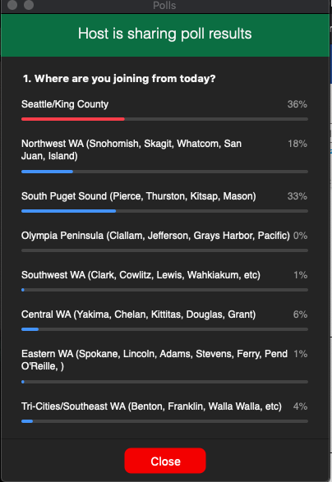  - What hats are you wearing?  - 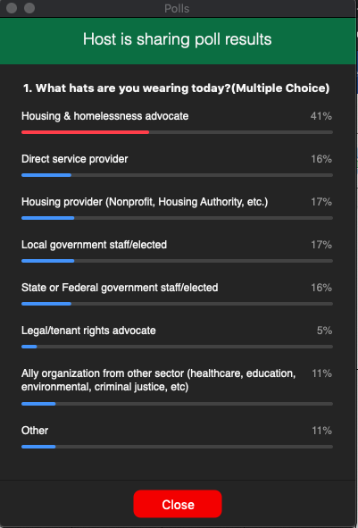
10:10  10 min  Emily | Updates from the Department of Commerce | Tedd Kelleher, Dept. of Commerce | - I can do this since you’ll do Nan  - Rent Assistance program ideas to help address the moratorium  - What does a program that promotes racial equity look like?  - Large challenge of a fast-moving problem of deadlines moving soon without a program launch and getting everything up in the state  - Nothing nailed down yet about what will be available; but hope this will happen. In the near term  - Tribal grant – working through those  - Sent out $40 mil shelter grant RFP  - City and county can apply separately; pre-pandemic this was part of the governor’s ideas to find a dignified place that we don’t have for people  - We don’t think this is enough money, but it is a good start to create a baseline system for people to have some sheltering capacity  - Diane Klontz: 1.6billion that came to WA state; pretty likely that we will get some funds that go to homelessness; Ted mentioned lots of options but majority will be for rent assistance and will ask people for feedback  - That will be a short period of time  - Another set of funding is around foreclosure for those who cannot pay their mortgage; trying to be inclusive and also support our landlords  - Thanks to all of you and our Commerce Team  - Rachael: When you ask for feedback we will be glad to spread the word to our members  - Q: Any updates on coronavirus relief funds (CRF) - $300M for cities and counties? Will commerce be tracking how those funds are being used?  - Which specific money?  - Referencing the funds from the federal gov’t $300m pool  - Diane: that is going through local government; we will make sure that it is going to the specific line items it is supposed to go to
10:20  10 min  Caroline | Assessing and improving meeting accessibility | Allexa Laycock, Disability Rights Washington | - Rooted in Rights  - Accessible meeting tips:  - Keeping everyone muted  - Taking detailed notes so people can focus on the meetings  - Impressed with Otter AI transcription, there is also live captioning and Cart?  - Be explicit with what will and will not be provided in a meeting; more info is better so people can decide, or they can request for accommodations  - ‘Make sure there is the phone call in number; deaf or hard of hearing can get better audio with phone  - Using headphones when possible so that audio captures  - Please send everything beforehand like agenda and slides so that people can use thier personal assistive devices to use magnification, color contrast, etc  - Everything screen shared is not accessible; we know this is a privacy concern, but in terms of accessibility this is helpful  - ‘When presenting, please describe all images that are on the slides  - Sick closely to what is on the slides, not word for word, but have it so both are available simultaneously  - Speak more slowly and clearly and are taking time  - Silence is okay, it’s ok to give time for people to respond in their time  - Use raise hand function  - Zoom silence is awkward but important to sit with it for a minute  - Important to have CART? Or ASL available; Otter tool and notes are also good  - Recommend Streamtext.net, that service is a real live person in your call, that will come up on a separate screen; this is customizable with contrast, location on screen since some items get blocked  - Make sure that an ASL interpreter is always available. Ask people to turn cameras off, hide all participants but presenter and ASL interpreter only  - You can pin the ASL interpreter, but you can do this for everyone  - If you book CART and ASL, then do this a week in advance and send content to providers so they are prepared to give the most accurate information  - Explain any and all acronyms; don’t assume they know what these are; send a guide ahead of time; we get caught up in our lingo and we forget, but it helps also for transparency  - Make sure everyone is introducing themselves when they speak; helps for everyone including people on the phone and post meeting transcript; makes it a lot clearer when you go back to reading it  - We have a blog post on our website that will have all these tips and more: https://rootedinrights.org/how-to-make-your-virtual-meetings-and-events-accessible-to-the-disability-community/  - https://rootedinrights.org/accessthat/  - I will share CART and ASL providers and I will send that to John after the meeting
10:30  15 min  Emily | The framework for an equitable COVID-19 homelessness response: guidance for communities | Nan Roman, National Alliance to End Homelessness | - (Slides)  - You all are receiving a sig amt of money to address homelessness from the CARES act – 4 billion for ESG, CDBG  - If we do our jobs well, more $ coming  - Important that we do our jobs well, that we use this $ strategically and wisely. Homelessness could shrink or grow depending on how we use these resources  - Use it to restructure homelessness approaches, need to use it to improve equity in our system  - 17x the amount we normally get in a year for ESG  - NLIHC and other orgs put together this framework  - This framework has commitment to address racial and income disparities  - Need to use funds to alleviate disparities not exacerbate  - Have people who have experienced homelessness in implementing response  - Collect data  - Another important value- imperative to help ppl with highest needs first, before folks with serious problems  - Only when all ppl are helped  - This should only be used for eviction and homelessness prevention once all ppl experiencing homelessness have been moved into housing  - If you are able to use it for homelessness prevention, it should only help people who have previously experienced homelessness  - Priority to get people into housing, best protection for ppl’s help and for a solid economic recovery is to get ppl into a home  - Need to use these resources to get ppl housed  - Succeeding means that you all have formed meaningful partnerships with public and private, also center POC and ppl who have experienced homelessness  - This needs to be done in weeks and months, not years  - 5 key areas, all of them need to be addressed:  - -Unsheltered people  - -Shelter  - -Housing  - -Prevention and diversion  - -Strengthening systems for the future  - Priorities should be addressing public health and crises, centering equitiy in your interventions  - Many unsheltered people will refuse to come in at first  - This is understandable because they have to give more than they get  - Need to lower barriers  - Congregate shelter is not a good place, immediate priority is to reconfigure  - All shelters should be low barrier  - Shorten length of stay in shelter by moving folks into housing  - Check with rapid rehousing folks to see if they need assistance.  - Goal is not more everyone into housing  - We’re going to need to get a bunch more money to do this  - It makes sense to go to scale with diversion asap: people who have experienced homelessness but who haven’t gone into the shelter system yet  - Next, we need to create better systems in the future.  - Establish partnerships with continuums of care (CoCs)  - Create a more just society by ensuring that everyone receives equal treatment  - We’re distributing this to policy makers and leaders throughout the country  - a document to help you operationalize it will be coming out shortly  - CDC issued guidance for non-congregate shelter  - Some counties are getting FEMA funds for non-congregate shelter  - This provides support to things like motel hotel, doesn’t help with case management, that needs ESG  - Prioritize: ppl who are positive COVID, ppl exposed, those who are vulnerable  - FEMA will pay 55% of reimbursement for this  - This is will fund all people experiencing homeless  - Shouldn't discharge ppl to unsafe spaces, they need to discharge to housing  - This needs to be renewed every 30 days (might be 45 days?)  - Other sources that you can use to pay for housing  - Most important thing is that congregate shelter isn’t good for ppl, not a good public health strategy, and that you shouldn't discharge folks to unsheltered status, only to housing  - https://endhomelessness.org/a-framework-for-covid-19-homelessness-response-responding-to-the-intersecting-crises-of-homelessness-and-covid-19/?utm_source=NLIHC+All+Subscribers&utm_campaign=e807515fbc-Framework_061620&utm_medium=email&utm_term=0_e090383b5e-e807515fbc-293260181&ct=t(Framework_061620)  - Rachael: encouraging Governor’s office to use FEMA funds, continue to push and help make the case as effectively as we can.  - Nan Roman: we have some sample letters on our website to send to FEMA, FEMA is very particularly, those will save everyone time  - Q: Our county has a 0% vacancy rate so it seems unrealistic to use our ESG funds for RRH- any thoughts about that?  - A: Things haven’t changed in housing supply yet, but in some cases there is stock. Rapid housing is challenging because by definition these are often high need people. This is going to be hard, but sending ppl back to the street isn’t the answer.
10:45  10 min  Caroline | Youth aging out of foster care | Liz Trautman, The Mockingbird Society | - Mockingbird Society working with young people working on policy to change systems  - Challenges for youth aging out of extending foster care during the pandemic  - Most people who turn 18 in foster care are eligible for extended foster care  - You age out of this on your 21st birthday, about 250/year  - Make sure they have the supports they need; may be unemployed, losing connections etc  - Advocates settled on proposal to light touch case management of 6 months, but this hasn’t been approved at the governor’s office  - About 60 youth right now aging out without support  - Bill --- Youth are not to be aged out into homelessness  - When moratorium expires, we want to be sure the youth are not going into homelessness  - This proposal is for $952,000  - Extended Foster Care has eligibility requirements that are liberal, in foster care and still in school or working  - State receives a match Title 4E  - Federal government after 21 years old is not matched so it is only the state  - People stay in foster home; or supervised placement; apartment, roommate, dorm, and receive a monthly stipend of $700/month  - Case Manager, case worker and attorney access – all lost at 21; “rug ripped out from under you”  - Exacerbated with pandemic  - Child welfare is disproportionate with Black and Native youth especially, most disproportionately is Native and Alaskan Youth  - Black also incredible  - Baked into the way our child welfare system works – Important overlay to this conversation  - Covid-19 has had a huge economic impact  - Seattle times noted that most significant pay impact are folx 18-29 years old; young folx are generally struggling economically  - Survey of foster youth 18-23 same numbers; 55% food insecurity; 21% in financial crisis as a result of pandemic; 72% have only one month of expenses covered; 48% lost job  - Some states have a moratorium on aging out of extended foster care  - Some are working on this rule change  - WA – we are working on this; this is not a philosophically challenge; people understand this;  - For those 20% in foster homes, once they are 21 they can’t stay unless they pass all of the requirements for being a foster parent; eviction moratorium would help people in their own home, but not those in foster homes  - Please call Governor’s office Chief of Staff and Office of Financial Management  - Key Message: Approve Emergency Funding for Youth Aging Out TODAY!
10:55  10 min  Emily | Special session update and budget update | Michele Thomas, Housing Alliance | - Thank you for your advocacy thus far!  - As you recall we cancelled last week's call b/c economic revenue forecast council’s presentation – this is the entity that makes projects for budget writing  - This meeting was to give an update on revenue projections, updating what the previous projections were  - Officially decrease of 4.5 billion dollars for this current budget, 4.3 billion dollar budget for the next biennium  - Leg will convene for a special session this summer  - When they convene in January for reg session, they will then grapple with the 4.3 bil deficit then  - They have a 50/50 chance of an optimistic or pessimistic, highly volatile, things are subject to change  - Governor’s budget office required each state agency to submit a 15% budget cut option to their office  - HEN increase of $16M were hard fought but not yet implemented; this looks like it could get cut  - This is a rental assistance program that helps folks across the state, hard fought to get first increase, and this increase isn’t enough to help folks  - The state has 3 budgets, operating budget is where the cuts had to come from, had to come from general fund dollars, where housing and homeless bills lives  - Structurally it encouraged it to come from this important program  - Human services will be hurt the most b/c of the way it’s structured  - Proposals of other state agencies isn’t necessarily what the GOV will approve  - What's will be cut hasn’t been decided yet  - A lot of lawmaker has lined up that they said that won’t allow cuts to HEN, but we must remain vigilant  - Good news: thus far Document Recording Fee revenue hasn’t seen reductions yet. Don’t know why, assumption was real estate was supposed to go down during COVID, assume because of refinancing  - Commerce gave a hint that there’s a conversation that  - Office of Financial Management considering releasing 100 mil for rental assistance, 10 mil for homeless prevention  - We think that ensuring the hardest hit communities (esp. POC, Immigrant, etc.)  - How to sustain tenancy once arrears are paid off? Devastating to households if the landlord is made whole, but the tenant still loses housing.  - Fed gov’t is where the bulk of our funds would have to come from  - Special session: talking about 2nd week of Aug, not official, not clear how long it will be. The policy has to be “fully baked”, no controversial policy will be considered during these. Eviction moratorium is considered into statute  - https://bit.ly/3dOo18b  - or via phone: 1 (833) 660-4877 and leaving a general message by selecting option 1.  - Eviction more is still in effect, AG is still enforcing that, if there's a concern reach our  - Prog rev on the table, but this is largely due to who we get in office. So get connected to the Washington Housing Alliance Action Fund in order to help get important representation in November.  - Considering 2021 priorities, want to hear input reach out to Michele: michelet@wliha.org
11:05  5 min  Emily | Federal Update | Rachael Myers, Housing Alliance | - Not a whole has changed, remains important  - No way state and local to address scale, need fed resources  - Last week of July to negotiate next COVID relief pkg  - Please continue to reach out, particularly Sen. Cantwell. She hasn’t signed on as a co-sponsor. Please reach out
11:10  5 min  Caroline | Board Resolution Campaign | John Stovall, Housing Alliance | - Around progressive revenue and how important this is - thank you everyone who is working for a robust package  - We need to pervade a growing movement ab=round progressive revenue; as an organization, please consider supporting this  - Any org with a board, please consider passing Progressive Revenue as a commitment; this is a document that y’all can come back to as a framework  - If you are an ED, board member, or case worker, “Can we have our board pass this?”  - We have a sample resolution draft up and I am happy to support this  - Board Resolution Interest Form: https://bit.ly/2Z2u9mQ  - Please contact John Stovall for support
11:15  Caroline | Back to Allexa for actions needed  Wrap-up & Adjourn |  | - Allexa: Wanted to touch on to advocacy efforts  - Really concerned deaths and cases in Coyote Ridge Correctional Facility  - Trying to get legislation passed to release geriatric prisoners.  - Once COVID hit, Disability Rights WA made recommendations about which populations that should be released  - Some were released, but not from populations that we have recommended  - We don’t expect them to be released at this point, but want people to let the governor know that people are watching and that action needs to be taken.

