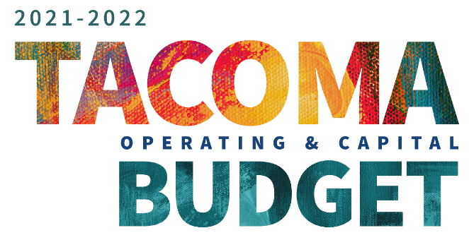
Share your thoughts!

Projected General Fund Expenses for 2021-2022 - $525.8 M
The City of Tacoma is currently preparing its budget for 2021-2022. With the economic impacts of COVID-19, we need your input on how to address our projected general fund deficit of about $67 million dollars (13%). The graph on the left shows how we currently fund our City Council priority areas of Access, Housing, Jobs, Safety, Health, and Community.

Given the projected deficit of $67 million dollars, where do you think we should make reductions or reinvestments?

Mark your selection with an X. Please only indicate one choice for each priority area.

Priority Area | Decrease Funding | Maintain Funding (No Change) | Increase Funding
Community Safety
Access to Facilities and Infrastructure
Job and Economic Recovery
Health and Social Services
Community Engagement
Housing

Zip Code:  To help us better understand the needs of different areas of Tacoma, please share your zip code.  __________________________________ | Race/Ethnicity (check all that apply)  - Asian  - Black/African  - Latino/Latinx/Hispanic  - Middle Eastern/North African  - Native American/Alaska Native  - Pacific Islander/Native Hawaiian  - White/Caucasian  - Rather Not Say

Racial Equity and Anti-Racism
The City of Tacoma is prioritizing racial equity and anti-racist action in our new budget to make sure it best serves Tacoma’s racially diverse community.
What do you think prevents the City of Tacoma from being a more equitable, anti-racist city? | What should the City of Tacoma do to create a more equitable, anti-racist city?

Community Safety
One of the City of Tacoma’s priorities is that Tacoma residents feel safe.
​What makes you feel unsafe in your community? | What should the City of Tacoma do to make you (and your community) feel safer?

Health and Social Services
One of the City of Tacoma’s priorities is to protect and improve the health of Tacoma and its residents.
What prevents you and your community from having what you need to feel healthy? | What should the City of Tacoma do to support the health of you and your neighbors?

Engagement
One of the City of Tacoma’s priorities is to make sure residents believe they can have a positive impact on their community and trust local institutions like the City of Tacoma.
What prevents you from trusting the City of Tacoma and other local institutions? | What should the City of Tacoma do to build trust with you and your community?

Access to Facilities and Infrastructure
One of the City of Tacoma’s priorities is that every resident have access to the services and facilities they want and need.
What prevents you from accessing the services and facilities you need? | What should the City of Tacoma do to create more access to the services and facilities you need?

Jobs and Economic Recovery
One of the City of Tacoma’s priorities is that Tacoma residents are able to get livable wage jobs in (or near) Tacoma.
What prevents you from getting a livable wage job? | What should the City of Tacoma do to create more access to livable wage jobs?

​Housing
One of the City of Tacoma’s priorities is to make sure that Tacoma residents are able to afford housing.
What prevents you from finding housing in Tacoma that meets your needs? | What should the City of Tacoma do to support housing needs in Tacoma?

