Weekly COVID-19 Housing & Homelessness Call
Wednesday, July 15th, 10-11:15am via Zoom
Time | Topic | Lead | Notes
10:00  5 min  Emily | Welcome & Settle in | Rachael Myers, Housing Alliance | - Call we do every week  - Goal is to share info and best practices, challenges  - Share ideas and info as needed  - A lot coming up at both federal and state level advocacy  - Eviction moratorium expires on August 1st  - Commerce can’t come today, working on  - Accessibility: if you would like a transcript, see Otter.Ai live notes, this is an AI, a robot, not a human. Will always take live notes.  - Welcome people to let us know if there are additional needs  - For speakers: Helpful to have camera on due to lip readers, try to speak as forcefully as you can.  - Reintroduce yourself so that Otter.AI can catch your name.
10:05  5 min  Caroline (question) / Emily (screenshot) | Poll Questions |  | - Where are you joining from today?  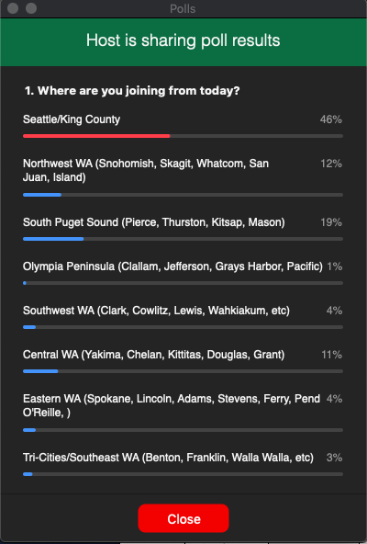  - What hats are you wearing today?  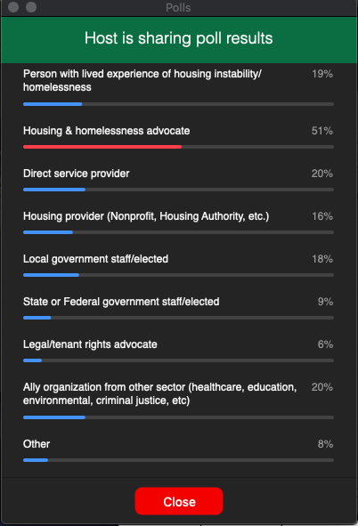  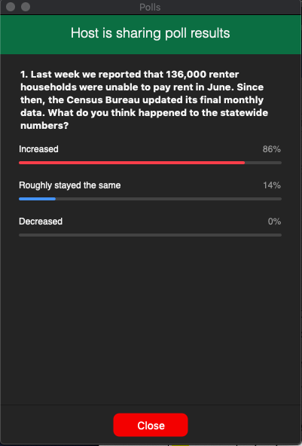  247,959 households who responded didn’t make rent in June  Household pulse survey link: https://www.census.gov/programs-surveys/household-pulse-survey/data.html
10:10  10 min  Teresa | Updates from Congress and what’s needed from advocates! | Congresswoman Suzan Delbene, 1st District | - Congresswoman Delbene is the prime sponsor for the Housing Credit Improvement Act which will increase the low income housing tax credit by 50% as well as an infrastructure package that will put more money into affordable housing. She represents Congressional District 1, from northeast King County up to the Canadian border.  - Affordable housing is a crisis that's only gotten worse since the pandemic started. Before we had 11 million households in the US who are already paying more than half of their income in rent, and now with 1 in 4 Americans applying for unemployment, our affordable housing needs are at an all time high. So it's important now more than ever that we address the affordable housing crisis with tools, like the Affordable Housing Tax Credit and Emergency Rental Assistance.  - Roughly 1/3 of US households were not able to pay their full housing costs for July, most of whom were renters. We also know that this pandemic is disproportionately impacting people of color. According to the National Low Income Housing Coalition study people of color are disproportionately rent burdened or homeless, as a result of structural racism. Often the lowest income renters are forced to make decisions between shelter, food, and other basic necessities. This is unacceptable and we have to demand change. The patchwork of federal, state and local eviction moratoriums are expiring and another month of rent will be due. We have to give Americans the help they need. A safe place to live has even stronger meaning during a public health crisis.  - In the US House we acted to extend the federal eviction moratorium and provide emergency relief rental relief to millions of Americans in both the HEROES Act and the Emergency Housing Protections and Relief Act, which have passed in the House and are awaiting consideration in the Senate. This month the House also passed H.R. 2, a big infrastructure package that includes several important affordable housing provisions like making the 4% housing credit permanent, lowering the bond threshold test from 50%, as well as a 50% state allocation increase, a basis boost for projects that serve extremely low income households, and inclusion of both rural areas and Native areas as so-called difficult development areas.  - This is a huge accomplishment. We’re waiting on the Senate to pick it up, so we have to keep up the momentum. I urge you all to keep reaching out to lawmakers to share your knowledge about the affordable housing crisis and emphasize that help is urgently needed. It's very important that lawmakers understand what it means on the ground in their communities. Those are the stories that all of you can tell that really make a difference.  - Congress will be back in session for the next 2 weeks voting on legislation. Our hope is that the Senate will start to move on another relief package, and hopefully pass the HEROES Act, so that we would be able to get legislation passed including housing provisions before the end of the month. I appreciate everything advocates and the Washington Low Income Housing Alliance are doing to ensure that people have a safe and affordable place to call home. I hope everyone can stay safe and stay healthy.  - Q: What can advocates be doing to support your work around housing stability?  - A: When we talk about things like tax credits, people don’t know how it will have an impact in their communities, I.e. the 4% minimum. Important to understand what it means in terms of how much more housing we’ll have available, how it impacts Native communities, etc. We as advocates can help take it from the abstract to the real. LIHTC program is definitely a complex program, but you don’t have to be a housing developer or understand all the ins and outs of the program to talk to your lawmakers about why it’s important. It’s the biggest housing production program in the country, has created # of homes in WA, and Rep Delbene’s bill would expand it by 50%.  - Q: In WA, fortunate all Democratic House members have signed onto the Rent Assistance Act. Sen Murray has also signed on, and we hope that Cantwell will as well since we know she is supportive of that. For folks in districts with Democratic lawmakers who have already said they’re supportive, why should we still reach out to them?  - A: It’s an urgent issue. We have projects that have been stalled or stopped. Everyone needs to know, even if they are already supportive, what projects in their region are impacted, and understand it’s something we can address right away. When supportive lawmakers feel that sense of urgency, they can push on their colleagues and correct them if they have the wrong information. The standalone tax credit bill has strong bipartisan support, but they could use more support so they have more leverage to push on the Senate. We know final bill will be negotiated down, so we have to be clear that housing is a must.  - Q: As Aug 1 approaches our state’s eviction moratorium and extended unemployment will end. What are the prospects for extending unemployment?  - A: the $600 extension is contentious and Republicans have been dismissive of the need to extend this. We’ll have to keep fighting for it. For families who’ve lost health care coverage, that extra payment can mean access to health care.  - There are more questions that we don’t have time to get to. One issue a few people have raised is that tenants are still having to pay more than 50% of their income in housing, and the hope that we’ll scale federal investments to meet that need. Legislation passed in the House will provide developers with incentives to create housing affordable to people living on the lowest incomes.  - We have a lot of work to do long-term. Please reach out to Congresswoman Delbene’s office and her staff will get you as much information as possible.
10:20  5 min  Kiki | Federal Advocacy – Virtual Lobby Day July 21 | Rachael Myers, Housing Alliance | - The stand alone billion in rental assistance bi partisan support? No – the bill with bi partisan is the tax credit. Rent assistance bill only has democratic support thus far  - Federal advocacy incredibly important right now. If you’ve been waiting for the right time to contact congress, it's now. They will back in session next two weeks  - Tuesday – NLIHC encouraging folks to participate in virtual lobby day. Ask your congress person if you can have a meeting – try for Tuesday, but really doesn’t matter. Try within the next week or two. Use the convo to talk about the needs in your community. John will drop link in the chat for more info on scheduling a lobby visit with WLIHA support  - Link:  - July 21st Virtual Lobby Day Sign-up: https://bit.ly/3erF6UB  - Also sending action alert probably Monday to please take action to federal level – need to turn up the volume/heat over the next couple of weeks. Risk of hundreds of thousands of folks losing their homes
10:25  10 min  Caroline | Improving the safety and seeking release of people in ICE custody during COVID-19 | Monserrat Padilla, Washington Immigrant Solidarity Network | - Monserrat Padilla, she/her/hers, I am one of the co-directors for Washington Immigrant Solidarity Network  - One of the protectors  - Over 250 organizations to organize support for when people need support to keep families together etc.  - We know that people can be pulled over or say detain someone during a work inspection – pipeline to deportation through Tacoma  - Lots of pain and damage to families  - Since Covid have had to adapt  - We knew that some safety nets would leave out some of our people  - Intentionally left out undocumented and mixed status families for stimulus relief due to xenophobia, discrimination, racism  - We have a community hotline 1-844-724-3737  - https://www.waisn.org/contact-us  - If you are in the community and see ICE agent, please call this hotline and let us know so we can come and document the situation and help  - This hotline has been used by primarily Latinx folx but this is multiethnic, network  - Mostly asked for financial support for housing because of lost jobs  - People left behind by state and federal leadership  - 1 - We’ve asked for 100M from Gov. Inslee to have the financial help to survive  - 2 – Covid, has been disproportionate for farmworkers. Ask is to support unemployment. Taxes are paid by everyone no matter your citizenship status. Immigrant people have been paying into this system. Important for people to have access  - Ensure roof over thier heads and food on thier tables, so there isn’t a choice to have basic needs or risk being sick  - Gov. Has agreed to help with #1 but no number yet. Economic relief  - Please stay engaged with us, and give out the hotline  - Washington state is a national leader on immigrant rights  - Thank you for being part of this movement to make sure our families are safe and healthy  - I look forward to continuing building collective power  - Rachael: Thank you so much! We’ll be sure to include your website and a reminder to support your actions. Stay in touch because this is a huge concern for how people are surviving in the agriculture industry  - Financial and otherwise.  - https://www.waisn.org  - Save this number in your phone WAISN HOTLINE: 1-844-724-3737  - From chat Leslie Brown: Please, if you can, donate to WAISN’s rent relief fund : www.scholarshipjunkies.org/relief  - Monserrat Padilla (Monserrat@waisn.org) - 1-844-724-3737
10:35  25 min  (see notes section) | Updates on local homelessness needs from around the state | Kathy Morgan, OlyCAP  Curtis Steinhauer, Welcome Home Skagit  Daisy Reyes, Pierce County Community Advocate  Elder Toney Montgomery, Tacoma Ministerial Alliance  Esther Magasis, Yakima County | Kathy Morgan (Emily)  - Update on sheltering folks  - When COVID started had issues distancing ppl in the shelter  - When $ came through we were able to pay for hotels, but became too expensive, then offered a site at the fairgrounds for 16k per month  - Offered the camping, a lot of people who don’t usually do congregate shelter came in to camp, # swelled  - This also became expensive  - When the camping opened back up to the general public we were given a 5-day notice to leave the campgrounds  - We have to go back to congregate sheltering with a lot less money  - We were able to keep ppl healthy  - Just about out of sheltering money for this year  - Our average age for our shelter is 65, where are they supposed to go when there’s no housing?  Curtis Steinhauer (Teresa)  - Curtis is with Welcome Home Skagit, a young grassroots organization. He and his wife spent 12 years being homeless and now have low income housing. He appreciates what Elder Toney said about systems being built to be oppressive, and targeting some groups more than others. Believes housing is a human right, a basic need for life, liberty, and the pursuit of happiness.  - Like Yakima County, Skagit County also has high rates of COVID among farmworkers. Recently over 60% people with confirmed cases were Latinx, many farmworkers. Lack of trust in government agencies and fear of ICE and border patrol, as well as a gross lack of affordable housing and shelter options, has compounded the challenge of containing COVID outbreaks.  - Skagit County only has permanent full-time shelters for youth, families, and certain individual singles, nothing for couples or elders. This year there were 2 winter shelters, but one shut down early on in covid and its operations will be impacted long-term by new congregate shelter guidelines. The other shelter had to shut down early as well due to an outbreak. They were able to move everyone to motels, but ran out of funds to provide those vouchers on June 1. Since then, community has seen an increase in unsheltered homelessness.  - Skagit Co never fully recovered from the great recession. With COVID, jobs have ended, businesses have closed. People are trying to figure out how to survive. Since the county went into Phase 2 they’ve seen increased case numbers. It’s really concerning. All of this has an impact on sheltering, with new guidelines from the state on congregate shelter.  - In Skagit shelter is financed through sales tax, no levy revenue like other counties. Looking at probably not having a winter shelter this year. So it will be a question of how much money the county can get to provide hotel vouchers for people through the winter.  - Looking to create a new full-time shelter that meets congregate shelter requirements where people are out of the weather and feel safe.  - We could be in COVID for the long haul. Hopefully the community will recover in fewer than 10 or 15 years this time.  Daisy Reyes (Emily)  - Here as Pierce County advocate, normally working with Pierce County health, as well as in Puyallup  - Pierce county challenges with the Latinx community  - Latinx families have been doubling up in their households  - A lot of the families were having 10 cases instead of just 1 case b/c multiple families were living in the same house  - Folks are scared to go to doctors due to fear of being deported  - Worked in a shelter, one of the things that was an issue was that due to not having documents they were not able to find housing or get social security benefits  - A lot of Latinx ppl are homeless, just not as visible b/c there is fear to be out there  - Big need in the Latinx community  Elder Toney Montgomery (Caroline)  - At the Tacoma Ministerial Alliance we have been contracted to provide services to African American community members by Catholic Charities  - Pierce County is just like any other county, homeless rate is much higher than other races  - 10% of pop and 30% of homeless pop  - This is endemic in every system in the USA  - It should be highly offensive to all of us that we have to even have this conversation right now. This is something we witness.  - Equity and equality should be the norm but we know it is missing.  - It’s akin to someone wetting on themselves: starts warm, then cold and stinking, starts to smell, then illness comes  - Covid – has allowed this to fester in so many communities  - Pierce County and the TMA contract, we feel that we can address this in a way that avoids all of the stereotypes – listed these; not Black excellence; people think about stereotypes that are engrained in so many hearts  - We’re using good tools; utilizing it with cultural competency that does not come with the judgement that you are “bad”  - Seeing that system is designed to hold you back; “We thank God for the ability to provide what the church has already provided but never had the money to provide.”  - Thanked people from Catholic Community Services, Associated Ministries and 211 to allow us to do this unhindered and with support  - We are hoping that the numbers of homeless Black folx are affected in a positive way  - Covid revealed this and we are going to address that  - Promise was to give each family 40 acres and a mule, if this would have happened: 156M acres - that would be just about half of Texas – If we would have had this, we would be an economic gem of prosperity. But when you don’t do it right, then generations that follow have to deal with it. All of us have the shoulders to bare this. So let’s do it!  - Chat: Thank you for calling out the shaming of people experiencing homelessness and the racist stereotypes commonly held against black people experiencing homelessness.  Esther Magasis (Kiki)  - Director of human services for Yakima county  - As a lot of folks probably know, Yakima county has had one of the highest rate of cases of covid. That rhetoric has been unhelpful or our community. Lots of convo in our community about folx who aren't wearing mask, sensationalization of the political stance on not wearing a mask but doesn’t take into account the high rate of poverty, especially mainly POC and farmworker communities  - A lot of folks who aren't able to work remotely due to nature of job and/or lack of infrastructure around tech access in the community and on the individual level  - That’s all to say that there is a really important aspect in the high rate of covid rates – those are economic and along racial lines  - Farmworker housing and farmworker safety – echoing some of the presentation earlier WISN. The workers protection haven't been worked out for a lot of farmworkers. Had a lot of lawsuits recently  - Housing safety and availability big focus I've been working on. Safety guide  - This is a premium example of how we don’t have the infrastructure for good internet in our community – even after paying to increase internet service.  - The state response to farmworker housing was a little bit inadequate. A lot of farmworkers live in farmworker housing through employers or nonprofit. Housing market already tight – really hard for them to find it on a limited 3-6 months basis. For folks how are migrant farmworkers, housing is a crucial component of safety and health. Also reduced the availability of bed in the farmworker housing – 6-foot rule doubles the space that was originally required. Number of beds reduced by half  - While increasing safety for covid decreasing safety for folks who are now pushed onto the streets or doubled up or sleeping in cars. They will still have contact with everyone else. They have relief from ESG in our county. Seems that the folks overseeing that in our county, a lot of farmworkers asking what resources available in our community – they were told they were provided an emergency housing grant and they should seek that grant out to use for housing. But the grant itself was issued based on point in time number, not the farmworker data. So now our county is seriously underfunded. We don’t have the resources now to respond to these farmworkers, essential workers, who aren’t able to take of work, etc.  - The expectation that we are going to support all these people who are already vulnerable with the limited grant we received, seems unreasonable. The response has been “this is what we already gave you make it work” doesn’t acknowledge the reality of what is happening on the ground here. The grant isn't structured in a way to serve that function.
11:00  5 min  Teresa | Update for homeless service providers and housing providers: channels for accessing PPE | Michele Thomas, Housing Alliance | - (ran out of time)  - Will be included in follow up email
11:05  10 min  Emily | Q&A |  | - (ran out of time)
11:15  Caroline | Wrap-up & Adjourn |  | - (ran out of time)

