Tacoma Pierce County Coalition to End Homelessness Weekly Meeting Agenda July 24th, 2020
9:00 | Voting in the era of COVID-19  Purpose: Ways we and out clients can pull the lever  Leader: Julie Anderson, Pierce County Auditor - julie.anderson@piercecountywa.gov
9:15 | Outreach Circle model to get the vote out  Purpose: Learn how to increase voter participation  Leader: Ann Williams - willar12000@yahoo.com and Nancy Dahl - nkdahl66@hotmail.com - League of Women Voters
9:45 | Small Group Breakout - Planning for the coming Tsunami  Purpose: Discuss plans or concerns about potential homelessness caused by the end of the eviction moratorium and the end of the federal unemployment support.  Leader: Gerrit Nyland, Coalition to End Homelessness – gnyland@pchomeless.org
10:25 | Elimination of Discrimination Investigators Update  Purpose: Understand Tacoma’s plan to eliminate housing and employment discrimination investigators  Leader: Gerrit Nyland, Homeless Coalition – gnyland@pchomeless.org
10:30 | Advocacy Update  Purpose: Understand the work  Leader: Maureen Howard, Senior Policy Analyst - maureenhowardconsulting@gmail.com
10:40 | Safe Parking Update  Purpose: understand what we need to do to support this work  Leaders: Janet Runbeck, RN, MN - janetrunbeck@gmail.com  Colin DeForrest, i2 Strategies - colin@i2-strategies.com
10:45 | Government Updates  Purpose: Understand the current efforts underway  - Manu Rodriguez, Tacoma Pierce County Health Department - mrodriguez@tpchd.org  - Ivan Tudela, Pierce County Emergency Management - ivan.tudela@piercecountywa.gov  - Valeri Knight, Pierce County Human Services - valeri.knight@piercecountywa.gov  - Allyson Griffith, City of Tacoma - agriffith@cityoftacoma.org
10:50 | Shelter Updates  Purpose: Updates about shelter operations  Nativity House, Adams Street, Tacoma Rescue Mission Men’s Shelter, Comprehensive Life Resources Young Adult Shelter, The Coffee Oasis Sara House, Catholic Community Services Family Day Center, MDC at Bethlehem Baptist, Altheimer, LIHI TEMS Shelter, Helping Hand House, Others?
11:00 | Networking  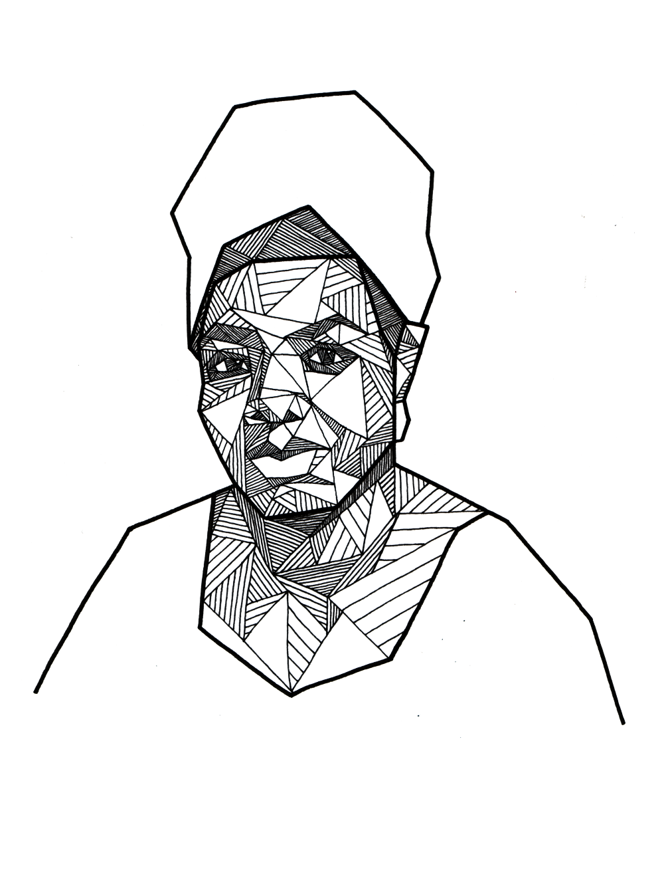  Purpose: “If you have only one smile in you give it  to the people you love.” – Maya Angelou
Next Meeting: Friday, July 31st - 9:00am
Contact Gerrit Nyland (gerritn@ccsww.org or 253-304-5105) to add an item to the agenda.
Resources, Listserv and Meeting info: http://www.pchomeless.org/

Committee 2019-20 Work Plans
Racial Equity |  | Leadership Team:  Heidi Nagel – Comprehensive Life Resources –  hnagel@cmhshare.onmicrosoft.com  Benjamin Feldbush, Comprehensive Life Resources -  bfeldbush@cmhshare.org
Charter: Better serve communities of color
Goals | - In Development

Workforce Development |  | Leadership Team:  Kelly Blucher, Goodwill - KellyB@goodwillwa.org  Sherri Jensen, Valeo Vocations sherri@valeovocation.org
Charter: Increase income through employment
Goals | - Get 10 organizations enlisted in the 253Works Job Club program  - Organize 3 Hire253 hiring fairs  - Increase Hiring success at Hire253 to 110% of all attendees

Advocacy |  | Leadership Team:  Cynthia Stewart – League of Women Voters - stewdahl@comcast.net  Carolyn Read – St. Leo’s - readcarolyn@comcast.net  Maureen Howard, Senior Policy Analyst maureenhowardconsulting@gmail.com
Charter: Advocate for better laws, policies and funding around housing and homelessness
Goals | - Connect to 4 other key advocacy groups around homeless issues  - Develop selected policy and funding action agenda for Pierce County, Tacoma and 2020 WA Legislature

Innovative Shelter Team |  | Leadership Team:  Theresa Power-Drutis, New Connections - tpdrutis@nctacoma.org
Charter: Increase temporary and permanent shelter stock for individuals with very low income
Goals | - Identify rural tiny house village site and agency to fundraise for and operate site  - Establish Tent City site and agency to fundraise for and operate site  - Advocate for other alternative, temporary shelter options: Safe Lot; Youth Shelter; Urban Rest-stop.

Community Connections |  | Leadership Team:  Richard Berghammer, FBC - ministrycounseling@comcast.net  Pamm Silver – Pamm.Silver@MolinaHealthCare.Com  Sheila Miraflor – Molina - Sheila.Miraflor@molinahealthcare.com
Charter: Increase housing retention and client stability with the newly housed
Goals | - Develop a Mentoring program with periodic care conferences are recommended.  - Maintain continuity of support, beginning with Stability Site (or wherever) to their home.

