FRIDAY, OCTOBER 2, 2020
9-10:30 a.m.

CANDIDATE FORUM

TACOMA PIERCE COUNTY COALITION TO END HOMELESSNESS

Please plan to attend our 2020 Candidate Forum, which will open our October 2 Coalition meeting. We have invited all the candidates for the 5 Pierce County positions we’ll be voting on this year, and will let the Coalition know prior to the forum who plans to be present. The format for the forum will be ‘listen-learn-summarize’ which will include 20-minute breakout sessions to allow individual Coalition members to speak directly to the candidates.

Since we do not have the Pierce County Voter’s Pamphlet available yet, we’re providing photos and links to each candidate’s election website, along with TNT editorials providing opinion on all the County races.

COUNTY EXECUTIVE

TNT editorial Comment on the County Executive Race: https://www.thenewstribune.com/opinion/editorials/article242829786.html

Bruce Dammeier – R
https://www.brucedammeier.com/

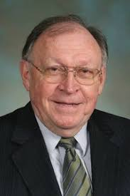
Larry Seaquist - D
https://www.larryseaquist.com/

COUNTY COUNCIL

TNT editorial Comment on the County Council Races:
https://www.thenewstribune.com/news/politics-government/election/article244934642.html

District 2

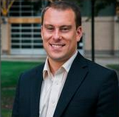
Hans Zeiger - R
https://hanszeiger.com/

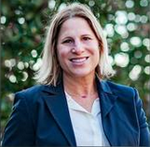
Sarah Rumbaugh - D
https://www.sarahrumbaugh.com/

District 3

Amy Cruver - R
https://www.electamycruver.com/

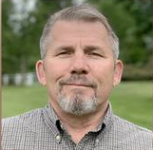
Joe Zaichkin – R
https://joezfordistrict3.com/

District 4

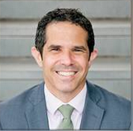
Ryan Mello - D
https://ryanmello.com/

Javier Figueroa – I
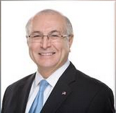
https://www.electjavier.com/

District 6

Jani Hitchin – D
https://www.electjanihitchen.com/

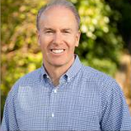

Jason Whalen – R
https://whalenforcouncil.com/

