3PM Cold Weather Update
December 29th, 2021, 3PM
Pierce County Human Services

Meeting Location: https://piercecountywa.zoom.us/j/95523208556
Meeting ID: 955 2320 8556
Dial by your location
+1 253 215 8782 US (Tacoma)
888 788 0099 US Toll-free
Meeting ID: 955 2320 8556
Find your local number: https://piercecountywa.zoom.us/u/adnQvG4cbE

Staff – John Barbee, Gerrit Nyland, Delmar Algee, Annie Marie Edwards, Sarah Appling, Bryan Barmore
Time | Agenda
3pm | Current Status – Cold Weather Update
Emergency Shelters/Shelter Expansion:
Agencies w/ Hotel Vouchers:
Warming Centers:
Churches Serving as Temp Shelter:
Information Hubs:
Inclement Weather Shelters:
Safe Parking Sites:
Distribution Centers

Open Discussion:
Recap of Action Steps:

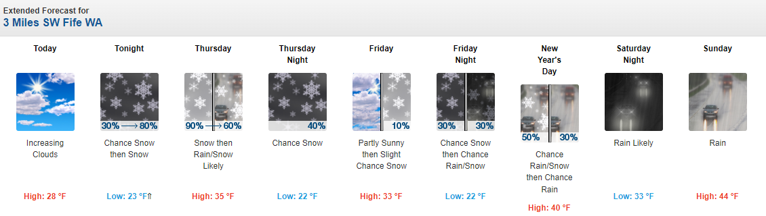
https://forecast.weather.gov/MapClick.php?lon=-122.41104125976562&lat=47.20913220827748#.YcoCAGDMKUk

Special Weather Statement

Special Weather Statement
National Weather Service Seattle WA
325 PM PST Tue Dec 28 2021

WAZ504-507-509>517-555-556-558-559-567>569-300000-
Southwest Interior-Everett and Vicinity-Tacoma Area-
Admiralty Inlet Area-Hood Canal Area-Lower Chehalis Valley Area-
Olympics-Eastern Strait of Juan de Fuca-
Western Strait of Juan De Fuca-North Coast-Central Coast-
East Puget Sound Lowlands-Bellevue and Vicinity-
Seattle and Vicinity-Bremerton and Vicinity-
Cascades of Whatcom and Skagit Counties-
Cascades of Snohomish and King Counties-
Cascades of Pierce and Lewis Counties-
325 PM PST Tue Dec 28 2021

...DANGEROUSLY COLD TEMPERATURES TO CONTINUE THIS WEEK...

Temperatures will remain unseasonably cold through the rest of
the week with highs in the upper 20s to mid 30s and lows in the
20s.

With these very cold temperatures, frost bite and hypothermia will
occur much faster. If outdoors, remember to dress in layers and
cover exposed skin.

Take precautions to protect pets and livestock from the extreme
cold as well.

Uncovered pipes will also be susceptible to freezing and
bursting.

$$

www.weather.gov/seattle

WWA Summary by Location for 47.19N 122.45W with WAZ509/WAC053/WAZ654 emphasis Special Weather Statement

