February 11, 2022

Representative Timm Ormsby Representative Steve Bergquist
Chair, House Appropriations Vice Chair, House Appropriations

Representative Mia Gregerson
Vice Chair, House Appropriations

Dear Chair Ormsby and Vice Chairs Gregerson & Bergquist,
We, the undersigned, respectfully encourage you to include a budget allocation of $78 million to support Washington’s frontline homeless service providers. While there are many worthy budget requests this year, we want to emphasize that our frontline providers are unsung heroes of the pandemic, and Washington’s ability to prevent and end homelessness rests on their shoulders. They work in extremely difficult, traumatic conditions with little pay, poor benefits and in increasingly understaffed situations. Our nonprofit providers are also hurting with high turnover and inability to recruit workers for open positions.
This one-time budget ask is being sponsored by Representative Macri and is co-sponsored by Representatives Leavitt and Shewmake.
The proposed budget investment will provide immediate relief by allowing workers to apply for a $2,000 stipend and will allow for a second stipend 6 months later if they continue to work for the same employer. The second stipend is designed to incentivize and reward retention. This stipend program will help stabilize the workforce while longer term solutions are identified.
$500,000 of this request is designated for a study overseen by the Department of Commerce on workforce related needs of nonprofit organizations employing homeless service workers and of nonprofit permanent supportive housing providers. The study will inform the legislature on state level strategies to improve retention, training, safety, pay and benefits, and must include input from frontline, essential service workers, workers with lived experience of homelessness, and BIPOC led organizations statewide, including organizations primarily serving BIPOC or grantee populations.

Please support this investment in our homelessness workforce,

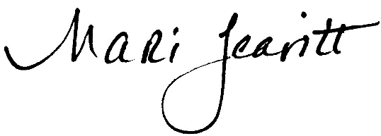
Mari Leavitt
State Representative
28th Legislative District

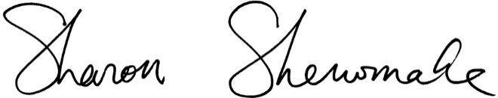
Sharon Shewmake
State Representative
42nd Legislative District

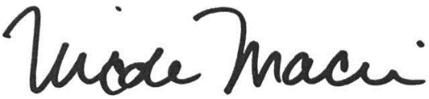

Nicole Macri
State Representative
43rd Legislative District

