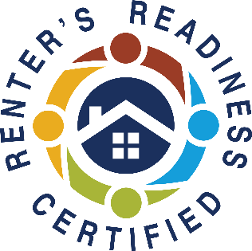

**Register Early and Get Reminders, or Register and Enter at Time of Class**

All classes are online ONLY

**REGISTER NOW!** <https://form.jotform.com/240786930917164>

Join zoom meeting <https://us06web.zoom.us/j/86997333549?pwd=RkcyUEthaFpObDF5bEF1dXpWQURpdz09>

Meeting ID: 869 9733 3549

Passcode: 283017

**CLASS 1 – Landlord/Tenant Rights & Responsibilities**

**Wednesday (September 25th, 2024) 1:30 PM - 4:00 PM**

Understand your rights and responsibilities under the landlord/tenant laws in Tacoma and Washington State. Typically instructed by Spinnaker Property Management, presented by Associated Ministries this month.

**CLASS 2 – Accessing Community Resources/Financial Capability**

**Thursday (September 26th, 2024) 10:00 AM – 12:00 PM**

Maintain your rental housing by utilizing community resources that offset costs in other areas of your life. Hear expert tips on how to search for housing, understand your lease, and become a knowledgeable renter. Also, learn how to set a budget and improve your credit score. Instructed by Associated Ministries.

*(Please note: participants must attend both sessions to receive the certification.*

*Classes do not need to be taken in order. Classes will be online.)*

**Join us online and earn your Renters’ Readiness Certificate for FREE!**

**A Renters’ Readiness Certificate boosts your rental application and provides you with powerful tools to become a strong renter. These classes are FREE and open to all housing shoppers, service providers, property providers, and community members.**

**For more information email the Housing Stabilization Team:**

[HSP@associatedministries.org](mailto:HSP@associatedministries.org) **or call HSC at 253.426.1503**

Renters’ Readiness Classes