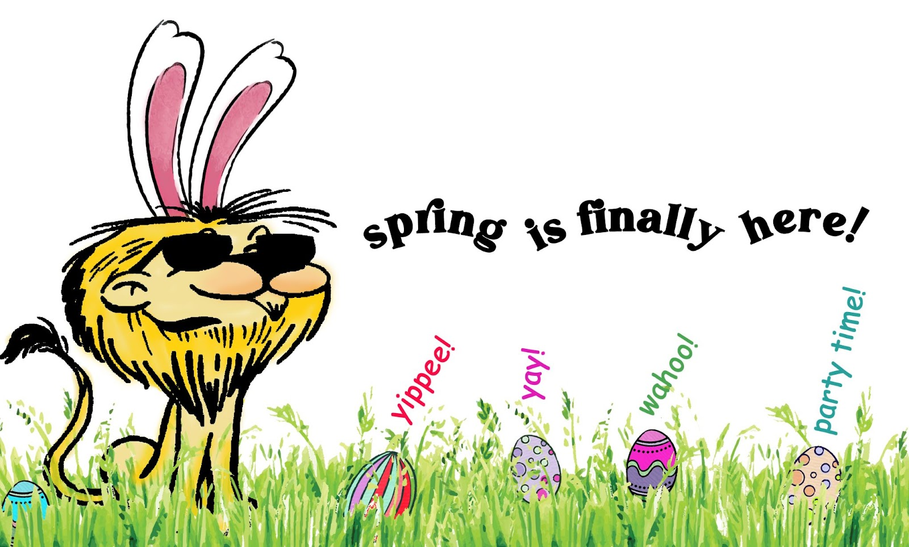
Please pass this information on to parents of blind & low vision children. The following are coming soon all with more details, but meanwhile here is a preview
2025
Audible Egg Hunts:
ALMOST

🐰SPRING PARTY🥕
& EGG HUNT

MD19 Lions Knights Of The Blind (KOTB) want all children who are Blind or have Low Vision to know about upcoming Audible Egg Hunts! These are the ones we know about now, but hope there will be more. Email colette.arvidson@gmail.com, if you want to be notified about more as we hear about them:

April 5th 2 – 4 pm
Maplewood Presbyterian, 19523 84th Ave W, Edmonds, WA 98026
Sponsored by Edmonds Lions & WCB Families
RSVP hididly@gmail.com (425) 366-9455

April 12th 10 am - Noon
Kent Senior Center, 600 E. Smith St, Kent, WA 98030
Sponsored by Green River Valley Combined Club of Legacy West Pioneers
RSVP: Marian Wilcox (206) 387-1860 mwilcox117@comcast.net

April 19th 10 am
710 176th St E, Spanaway, WA
Sponsored by Spanaway Lions
RSVP – Lion Andy (253) 224-2948

April 19th 2 pm
United Methodist Church, 2201 H Ave, Anacortes, WA
Sponsored by Anacortes Lions
RSVP colette.arvidson@gmail.com (360) 391-5880

