**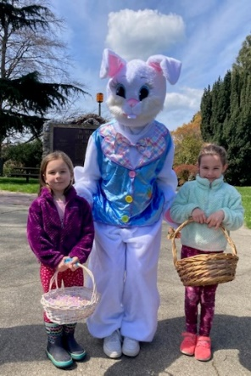Join Lion Leo &**

**the Friendly Bunny**

**Anacortes Lions**

**Causland Park**

**Community Egg Hunt**

**Sunday – April 20, 2025 - 1 pm**

**1116 8th Street, Anacortes, WA 98221**

**Bring your basket and camera for photos with our special guests!**

***No Registration Required for Causland Park Community Egg Hunt.***

** Lions also sponsor *2 Very Special Egg Hunts***

**Saturday, April 19, 2025**

**1 pm: for Children with**

**Special Needs**

**2 pm: Beeping Eggs for**

**Children who are**

**Blind or Low Vision**

**United Methodist Church, Boyd Hall**

**2201 H Avenue, Anacortes, WA**

**Registration Required for Special Hunts by April 14, 2025 - Contact Lion Colette at (360) 391-5880** [**colette.arvidson@gmail.com**](mailto:colette.arvidson@gmail.com)