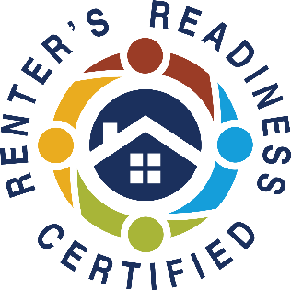
CLASS 1 – Landlord/Tenant Rights & Responsibilities
Friday (September 26th, 2025) 10:00 AM - 12:00 PM
Understand your rights and responsibilities under the landlord/tenant laws in Tacoma and Washington State. Presented by LLP at Associated Ministries.
CLASS 2 – Financial Capabilities
Monday (September 29th, 2025) 10:00 AM – 11:00 AM
Learn how to set goals, budgeting and improve your credit score. Instructed by RRH at Associated Ministries.
CLASS 3 – Accessing Community Resources
Monday (September 29th, 2025) 11:00 AM – 12:00 PM(must attend class 2)
Maintain your rental housing by utilizing community resources that offset costs in other areas of your life. Instructed by LLP at Associated Ministries.
(Please note: participants must attend all sessions to receive the certification.
Classes do not need to be taken in order. Classes will be online.)
Register Early and Get Reminders, or Register and Enter at Time of Class
All classes are online ONLY
REGISTER NOW! https://form.jotform.com/240786930917164
Join zoom meeting https://us06web.zoom.us/j/86997333549?pwd=RkcyUEthaFpObDF5bEF1dXpWQURpdz09
Meeting ID: 869 9733 3549
Passcode: 283017

Join us online and earn your Renters’ Readiness Certificate for FREE!
A Renters’ Readiness Certificate boosts your rental application and provides you with powerful tools to become a strong renter. These classes are FREE and open to all housing shoppers, service providers, property providers, and community members.
For more information email the Housing Stabilization Team:
HSP@associatedministries.org or call HSC at 253.426.1503

Renters’ Readiness Classes

