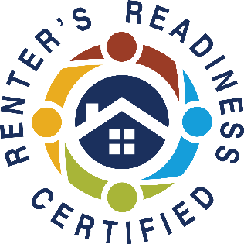

Join us online and earn your Renters’ Readiness Certificate for FREE!
A Renters’ Readiness Certificate boosts your rental application and provides you with powerful tools to become a strong renter. These classes are FREE and open to all housing shoppers, service providers, property providers, and community members.
For more information email the Housing Stabilization Team:
HSP@associatedministries.org or call HSC at 253.426.1503

Renters’ Readiness Classes

CLASS 1 – Landlord/Tenant Rights & Responsibilities
Understand your rights and responsibilities under the landlord/tenant laws in Tacoma and Washington State. Presented by LLP at Associated Ministries.
CLASS 2 – Financial Capabilities
Learn how to set goals, budgeting and improve your credit score. Instructed by RRH at Associated Ministries.
CLASS 3 – Accessing Community Resources
(must attend class 2 same day)
Maintain your rental housing by utilizing community resources that offset costs in other areas of your life. Instructed by LLP at Associated Ministries.
(Please note: participants must attend all sessions to receive the certification.
Classes do not need to be taken in order.)
Upcoming classes:
April
Class 1 - April 17 (Friday) 10 AM – 12 PM
Register Early and Get Reminders, or Register and Enter at Time of Class
All classes are online ONLY
REGISTER NOW! https://form.jotform.com/240786930917164
Join zoom meeting https://us06web.zoom.us/j/86997333549?pwd=RkcyUEthaFpObDF5bEF1dXpWQURpdz09
Meeting ID: 869 9733 3549
Passcode: 283017

Class 2 - April 20 (Monday) 10 AM – 11 AM
Class 3 - April 20 (Monday) 11 AM-12:30PM

May
Class 1 - May 12 (Tuesday) 1 PM – 3 PM
Class 2 – May 13 (Weds) 1 PM – 2 PM
Class 3 – May 13 (Weds) 2 PM – 3:30 PM

June
Class 1 – June 9 (Tuesday) 1 PM – 3 PM
Class 2 – June 10 (Weds) 1 PM – 2 PM
Class 3 – June 10 (Weds) 2 PM – 3:30 PM

