
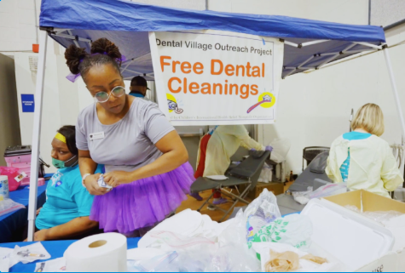

Free Dental cleanings will be offered at Project Homeless Connect
on Tuesday, September 22, 2026.

We will have capacity to treat the first 35 patients.

