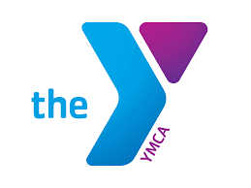The Bridge of Hope

YMCA of Pierce and Kitsap Counties

*Creating a community strengthened by Difference ~ connected by Trust*

Let me introduce you to the YMCA Bridge of Hope community initiative.

Our community is challenged. In recent years we have all experienced a breakdown in communication, problem solving, and relationships. Increasing polarity in our personal relationships, all of society and politics manifests as win/lose debates, fear, distrust, governmental dysfunction and a general sense of exhaustion, and hopelessness.

The purpose of the Bridge of Hope is to gather people within Pierce and Kitsap Counties who desire to increase civility, understanding, hope, and trust by participating in meaningful civil dialogue around complex issues with those of differing experiences and perspectives.

The YMCA recently held a Community Talks, Community Listens session designed to bring forth potentially divisive issues of concern. Based on the community feedback, the dialogue **Exploring the Complexity of Homelessness in the Gig Harbor Key Peninsula Community** will be held at **Tom Taylor YMCA in Gig Harbor Wednesday, February** **1st, 6:30PM to 8:30PM.** You are invited to participate!

The YMCA has been collaborating with Essential Partners who provide 30 years of expertise in reducing polarization and strengthening belonging within communities through dialogue. Please view this introductory video to [Essential Partners](https://www.youtube.com/watch?v=msaJrj4bHqo). Our dialogue on February 1st will be a place where all are given the opportunity to listen and learn with others and share values, perspectives and stories on the important topic of homelessness in our community.

We anticipate participants in this dialogue will experience increased understanding and trust of others who have different experiences and perspectives around the concerns and challenges we all face regarding those living with homelessness.

If you would like to participate in the dialogue on February 1st, please fill out this [Jotform](https://www.jotform.com/223265053935153). This QR will also link you to the registration form.

If you want more information about Bridge of Hope community initiative, please contact:

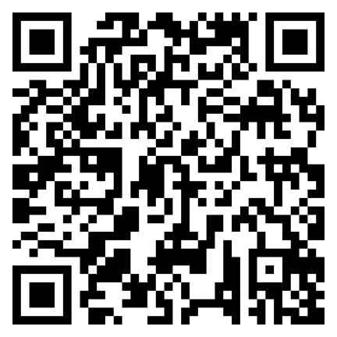

Paul Schneider [pauldschneider43@gmail.com](mailto:pauldschneider43@gmail.com)

Linda Calbom [lmcambom@comcast.net](mailto:lmcambom@comcast.net)

Lew Napolitano [lew.lifelonglearning@gmail.com](mailto:lew.lifelonglearning@gmail.com)

Efrain Gonzalez [egonzalez@ymcapkc.org](mailto:egonzalez@ymcapkc.org)

We hope you will join us.