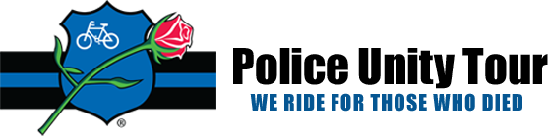

Please join us in honoring all Law Enforcement officers, by supporting our own Pierce County Deputy Sheriff Nathan Betts as he participates in the national “Police Unity Tour” 300-mile bike ride to honor officers who have died in the line of duty. Ride is May 9th – 12th, 2023.
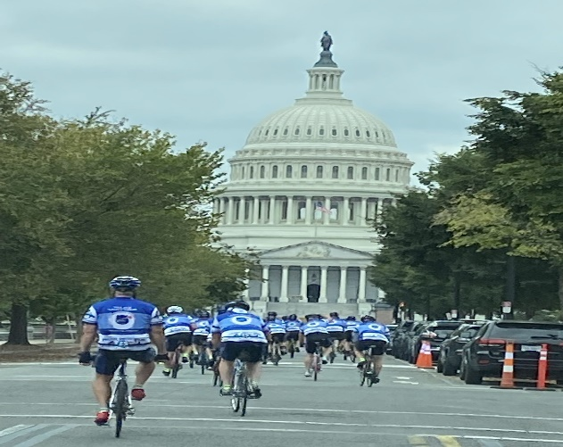

Nathan is committed to raising funds to support this event. Let’s put him over the “top” with donations and recognition of his commitment and dedication!

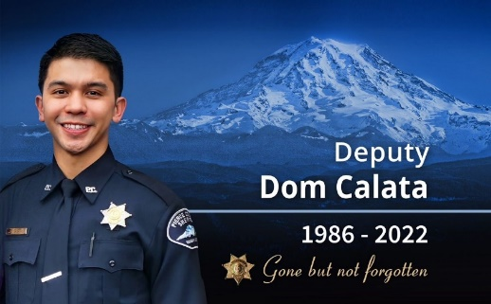

Nathan is riding in recognition and remembrance of Deputy Dom Calata / #440.

Pierce County Sheriff's Deputy Dom Calata died on March 16th, 2022, from injuries sustained during a shooting as part of a SWAT operation on March 15th, 2022. Deputy Calata, 35, served with the Pierce County Sheriff’s Department for 6.5 years and was assigned to patrol with the Edgewood Police Department.

Donations can be made through April 15, 2023
2023 Police Unity Tour Ride

