|  |  |
| --- | --- |
| **Communities of Focus**  ***Resident & Partner Meeting***  ***January 28, 2025|10:30-11:30 a.m.*** |  |

**Zoom Link**: https://us06web.zoom.us/j/87574172336?pwd=AwAlE4IK1I6Nl1p9iHcd49Cvn9LP2R.1

**Meeting ID**: 875 7417 2336 - **Passcode**: 358305

**Facilitators**: Marcy Boulet & Daniel Burdsall **Note-taker**: Tony Smith

Participant total - 42

**Agenda**

* ***Welcome and Quick Introductions* (5 mins) – Daniel Burdsall** 
  + Celebrate 2024 and our journey through the year.
  + Share 2024 outcome data.
  + Share via PowerPoint slide.
* Focused on improving health conditions through strategies that include Investments, Partnerships, Civic Engagement, Capacity Building.

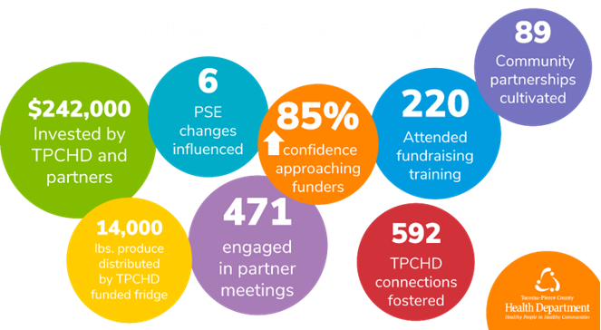

* ***Quick CoF Overview & Agenda* (5 mins) – Daniel Burdsall**
* ***Land Acknowledgement* (5 mins) – Marcy Boulet**
* ***Community Partner Assessment* (20 mins) – Marcy Boulet/Leah Ford**
  + Community Health Assessment purpose and future uses.
  + Timeframe and next steps.
* ***CoF Meeting Topic List for 2025* (10 mins) - Tony Smith**
  + Show group topic list. Feedback on what to prioritize this year.
* ***Updates from Community* (if time is left) – Marcy Boulet**
* ***Closing* (5 mins) – Tony Smith**
* Next CoF Resident & Partner meeting.
  + **February 25, 10:30-11:30 a.m. over Zoom.**
* In November, Tacoma-Pierce County Health Department teamed up with Virginia Mason Franciscan Health to provide a free virtual training on proposal writing.
  + If you would like free access to the electronic recording, please share your interest with us and we will ensure you get access.
* If you would appreciate having this meeting populate into your calendar for the entire year, you can find the meeting series invite in the email i sent to you last week. If you didn’t get one, please reach out.
  + Also, go ahead and delete the CoF Partner mtg invite created by Krystle Amundson as it is an old invite.
* You can reach us at [**communitiesoffocus@tpchd.org**](mailto:communitiesoffocus@tpchd.org).
* ***Adjourn***

**Participants # - 43**

**Notes**

* ***Community Partner Assessment w/ Leah Ford (Community Health Program Manager)***

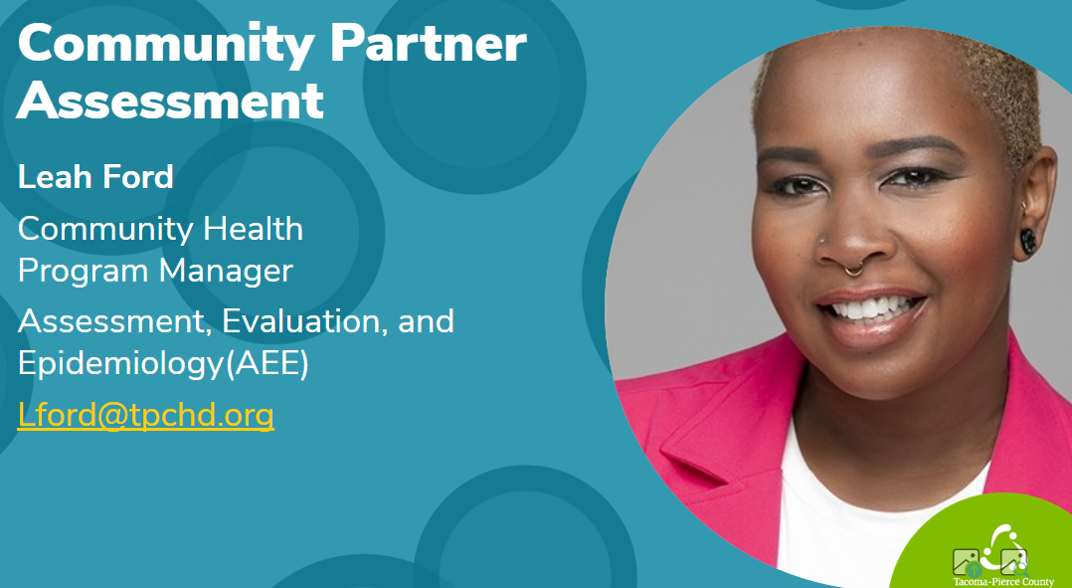

* Started updating health equity metrics starting in Nov 2022,
* The Data Team is focused on making resources more relevant to community at large – more dynamic and interactive
* Making sure that data metrics are practical, accessible, realistic for community
* Wanting to make a one-stop shop for everyone to access data and use easily within communities
* In past meetings about indicators, we identified which to keep and what to leave out, such as the Social Vulnerability Index(SVI).
* In Aug 2024, we launched the social pinpoint website to hear from community on which health indicators should be used in 2025 and beyond.
  + Thank you for your feedback!
  + Currently analyzing community feedback on those indicators
* A partner mapping tool that identifies key stakeholders is coming soon.
* Additionally, the TPCHD data team is working on community health needs assessment with VMFH and Multicare – will be sharing more when that process is complete
* Please help fill out the community partner assessment survey to share your invaluable insights of your community – assesses strengths, challenges, areas of need, CoF
  + [Community Partner Assessment for Tacoma-Pierce County Community Health Needs Assessment](https://forms.office.com/Pages/ResponsePage.aspx?id=5Kj32tfFQ0e-gC9zkXEvJJyWkF5NcJNDi3jaES9ZgRZURTFJQlJWSVMwWUpSVVpQRzRJVk9NN0FURi4u)
  + Deadline is Feb 28th
* Will follow up with you all on how the CPA feedback helped develop the health indicators we determine
* WA DOH recognized the processes that community has participated in, and cited our efforts, setting a strong standard for equitable community.
  + They intend to include the work in their core health indicators
  + Pierce county set a strong standard for community engagement.
* Will share the link in the chat and email – deadline is Feb 28th
  + Please help fill it out as it leads to new health indicators that will be available for the public to use.
* Leah and Suzy attended the national American Public Health Association (APHA) conference to share about the social pinpoint project based on the collaboration from community and folks in CoF.

Susan Paganelli - do your maps have any connection to the Pierce County maps that were just redone?

* No, TPCHD maps are separate.
* But Pierce County’s equity index is a helpful tool, which relies more on the SVI.

Maria Teresa Gamez - Do your maps / data cover language access?

* Yes, it is one of the health indicators in fact and more will be developed to make it language accessible to the public.
* ***COF Meeting Topic List w/ Tony Smith***

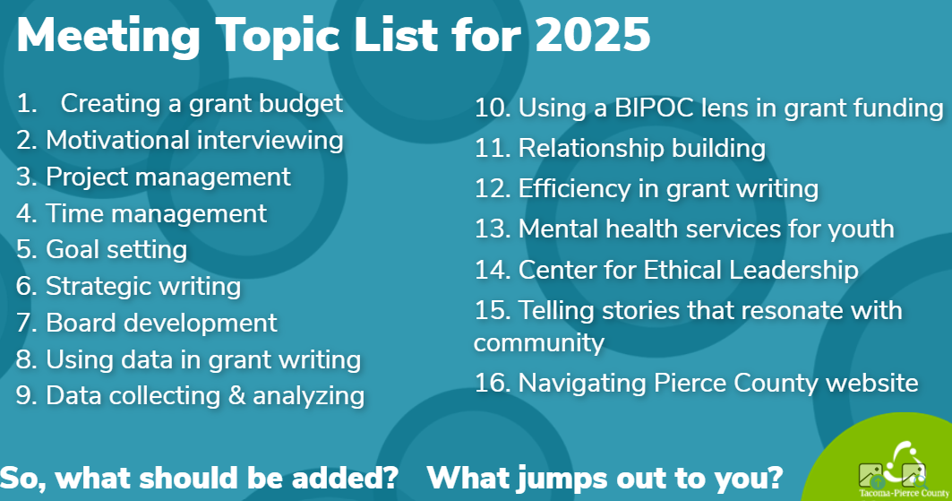

Willow Eaton: As the Director of a nonprofit that seems to change direction in a heartbeat, i think Goal Setting would be helpful.

* Goal setting that is flexible is needed for leading a non-profit – helpful to know how to adapt
* How to drift for funds but ensure you don’t stray too far from your goals, so they are intact.

Program management goal setting (Alicia Klein)

Time management (Alicia Klein, Quenna, Leah Ford)

Alison Eckes – PCLS – Relationship building – focused coalition building across the county – new strategic plan and looking at how we prioritize resources for greatest current partnerships and strengthening relationships

Jennifer Pollard - Grant for food bank truck

* ***Community Updates***
  + **Tatiana Yepes -** [**CPIN WA Working Families Tax Credit Workshops**](https://www.thecpin.com/working-families-tax-credit) (supports 8 counties)
    - Raymond Public Library (507 Duryea Street, Raymond, WA 98577)
      * Saturday, Feb. 1, and Saturday, Feb. 15, 10:30 a.m.-5 p.m.
    - Ilwaco Public Library (158 1st Ave N, Long Beach, WA 98631)
      * Saturday, March 1, 10 a.m.-3 p.m.
    - Pacific County Immigrant Support Group
    - White Salmon (for area farmworkers), Feb. 28-March 1
    - If you would like to collaborate and bring this opportunity to your community, reach out to [Tatiana Yepes](mailto:tyepes@thecpin.com?subject=WA%20Families%20Tax%20Credit).
  + **Queena Tupou - Blue Zones Parkland/Spanaway** 
    - Hosting free events in Parkland. No cost to community.
    - Zumba, yoga, financial wellness series in partnership with Habitat for Humanity. Healthy cooking demonstrations.
    - 1st Blue Zones school, health and wellbeing initiatives.
    - PLU is the 1st worksite for BZ.
    - Celebrations coming in March-May at PLU.
    - Work around policy, food systems, tobacco and alcohol prevention.
    - Working with LIWH, discussions focused on capturing voices from Black/African American community 2nd week of February.
    - More information here: <https://parklandspanaway.bluezonesproject.com/events/>
  + **Tax help at Pierce County Libraries**
    - <https://mypcls.org/learn-explore/government-law/tax-information/>
  + **Delia Flores - Parks Tacoma**
    - Name change from Metro Parks Tacoma to Parks Tacoma.
    - Hosting a [Community Workshop](https://www.parkstacoma.gov/event/swan-creek-bridge-workshop/) at Eastside Salishan Family Investment Center tonight, 1/28 at 6 p.m. to discuss a bike and pedestrian bridge. Join in a community discussion.
    - Pros and cons of each of the 3 locations.
    - Contact Delia Flores at [Deliaf@tacomaparks.com](mailto:Deliaf@tacomaparks.com) with questions and for more information.
  + **Sarah Atwood - Center for New Democratic Processes**
    - Working closely with CoF and Cindy Haverkamp.
    - Starting to do some of the work leading up to dialog groups in WR and KP, as well as Eatonville, Elbe and Ashford areas next fall.
    - If you’re interested in learning more, please contact Sarah Atwood at [Sarah@cndp.us](mailto:Sarah@cndp.us).
  + **Pierce County Sustainable Resources**
    - Has a grant workshop coming up and will be sending out more information later this week. Please reach out to [Nicole.avendano@piercecountywa.gov](mailto:Nicole.avendano@piercecountywa.gov) if you have questions!
  + **Transformational Ministries**
    - Jennifer Pollard – friend runs an org out of her own pocket – truck has broken down – trying to learn more about grants to use.
    - Currently found a grant for their fruit.
    - Wants to learn more about grants to help support their friend.
    - With their ministry they support foster care and special needs for adults.
    - It’s a large org they are running out of their pocket.
    - Tracks over 100 people coming through – lots of people which requires grant funding at this point.
    - Transformation is the non-profit organization - operates out of Tacoma – run their foodbank at a Spanaway church.
    - Unsure of the organization’s non-profit status, Jennifer Pollard will ask.
    - Jennifer Pollard - [Lulubell19@gmail.com](mailto:Lulubell19@gmail.com). Related to Kirby Pollard (father).
      * This would help them be able to accept grants and funding.
    - <https://tpchd.org/health/health-equity/communities-of-focus/> for grant video and materials. We can send more information.
    - Can send grant info to Jennifer Pollard, as well as connect community to other local orgs around food, too, would be helpful to know of the other local food resources, too.
    - Marcy will share Nourish food bank resources to Jennifer - [Lulubell19@gmail.com](mailto:Lulubell19@gmail.com).
  + **KP Mustard Seed Project**
    - Norm Mcloughlin.
    - Federal funding is frozen, consider focusing on state and philanthropic funding.
    - Please share any resources or opportunities.
    - Timberline Library Grants review system – gov and private sources.
    - South Sound Philanthropic Association.
      * League 10.
    - GTCF could be a valuable speaker at a future CoF partner mtg.
      * Estate funding and donor grants.
    - Tacoma Habitat for Humanity is a good contact to connect with.
* ***Closing***

**Zoom Chat Notes**

**10:33:47 From Jessica Widmer, Key Center Library to Everyone:**

Jessica Widmer, Key Center Pierce County Library, jwidmer@piercecountylibrary.org

**10:34:02 From Charlotte Shippley-KPPHC to Everyone:**

Charlotte Shippley, Community Health Worker with KP Partnership for a Healthy Community - chw@kphealthycommunity.org - (253) 400-7072

**10:34:07 From Eurydice Pentz (she/her) | Pierce County to Everyone:**

Eurydice Pentz, Pierce County Sustainable Resources (on Nicole's team) Eurydice.pentz@piercecountywa.gov

**10:34:09 From Tiffany Speir to Everyone:**

Tiffany Speir, Planning Division Manager, City of Lakewood tspeir@cityoflakewood.us

**10:34:14 From Erika Bartlett - EH Policy and Legislative Liaison - TPCHD to Everyone:**

Erika she/her TPCHD Environmental Health Policy Coordinator

**10:34:46 From Nicole Jones-Vogel to Everyone:**

Nicole Jones-Vogel, Assistant to Councilmember Robyn Denson. Nicole.Jones-Vogel@piercecountywa.gov

**10:34:48 From Stephanie Christensen to Everyone:**

Good morning, Stephanie Christensen, Community Health, VMFH

**10:34:58 From Arely Dominguez (PSESD) to Everyone:**

Arely Dominguez, she/her.ella

PSESD- Latinx Family Advocate/ Community Resource Navigator Orting FRC

**10:35:07 From Tatiana Yepes to Everyone:**

Tatiana Yepes, Collaborative Partners Initiative, Community Outreach Specialist, tyepes@thecpin.com

**10:35:31 From Dean Frazier to Everyone:**

Hi Everybody, Dean Frazier, Molina Healthcare, Community Engagement, Medicare dean.frazier@molinahealthcare.com

**10:35:42 From Rosario Bautista Gonzalez to Everyone:**

Rosario Bautista Gonzalez Community Outreach Specialist with PCECN and HopeSparks rbautista@hopesparks.org she/ her

**10:35:49 From Queena Tupou to Everyone:**

Good morning~ Queena Tupou, Executive Director - Blue Zones Project Parkland-Spanaway, queena@bluezones.com.

**10:36:14 From Jennifer Pollard to Everyone:**

Transformational Ministries food bank. On Sat. Other than first Sat. 202 170th St. E Spanway WA98387

**10:38:25 From Jennifer Pollard to Everyone:**

Transformationalministries444@gmail.com

**10:39:12 From Jennifer Pollard to Everyone:**

We start at 9:30-11:30am

**10:39:32 From Michael Swenson to Everyone:**

Hi Everyone, Michael Swenson, Exec Dir for Pierce County Project Access. We connect people to free healthcare who face challenges in obtaining it. Michael@pcprojectaccess.org. We increased our patients served by nearly double since October last year.

**10:39:35 From Stephanie Christensen to Everyone:**

Thank you to Tony - he directed me to the right meeting link today!

**10:40:47 From Marcy Boulet (she/her) to Everyone:**

Sorry everyone, about the old vs new link. If you have a link from Krystle Amundson, please delete that one, and use the monthly link that comes from Tony Smith :)

10:41:33 From Maria Teresa Gamez to Everyone:

Maria Teresa Gamez. Language Access Coordinator - City of Tacoma + TPU. mgamez@cityoftacoma.org

**10:43:38 From Jennifer Pollard to Everyone:**

Lulubell19@gmail

**10:44:03 From Mollie Meyer-EFN to Everyone:**

MollieM@efoodnet.org

**10:48:42 From Marcy Boulet (she/her) to Everyone:**

You as residents and partners were instrumental over the past year giving input into what data would be most helpful on our website. You also told us to keep focus on increasing assets as well. We thank you!

**10:49:43 From Susan Paganelli to Everyone:**

I forget - do your maps have any connection to the Pierce County maps that were just redone?

**10:54:32 From RaTanya Ozolin to Everyone:**

Thank you for the thorough update Leah!

**10:54:37 From Leah Ford (she/her) to Everyone:**

Learn more! Community Health Assessment - Tacoma-Pierce County Health Department

**10:56:51 From Maria Teresa Gamez to Everyone:**

Do your maps / data covers language access?

**10:57:18 From Leah Ford (she/her) to Everyone:**

Click Here to Take the Survey! Please complete by February 28th.

**10:58:05 From Cindy Haverkamp, she/her, TPCHD, Climate Justice Coordinator to Everyone:**

Thanks, @Leah Ford (she/her)! Look forward to chatting about this Thurs!

**10:58:37 From Queena Tupou to Everyone:**

Thanks Leah!

**11:00:11 From Willow Eaton; KPCS to Everyone:**

As the Director of a nonprofit that seems to change direction in a heartbeat, i think Goal Setting would be helpful.

**11:00:18 From Carmen Lewis to Everyone:**

I have to hop off for another meeting. I look forward to joining again next month!

**11:00:45 From Jennifer Pollard to Everyone:**

Grant for food truck

**11:05:07 From Marcy Boulet (she/her) to Everyone:**

Thanks, Alison! Good point about linking to our strategic plans.

**11:07:20 From Delia Flores (she, her, ella) to Everyone:**

Swan Creek Pedestrian & Bicycle Bridge Community Workshop - Parks Tacoma

**11:07:49 From Queena Tupou to Everyone:**

https://parklandspanaway.bluezonesproject.com/events/

**11:10:55 From Jessica Widmer, Key Center Library to Everyone:**

Tax help at Pierce County Libraries https://mypcls.org/learn-explore/government-law/tax-information/

**11:11:09 From Daniel B to Everyone:**

I see some PCLS and TPL folks here, perhaps a collaboration between CPIN for tax support in Pierce?

**11:11:26 From Tatiana Yepes to Everyone:**

<https://www.thecpin.com/working-families-tax-credit>

**11:11:43 From Marcy Boulet (she/her) to Everyone:**

Know Your Immigration Rights Feb (1).png

**11:12:14 From Tatiana Yepes to Everyone:**

Replying to "I see some PCLS and TPL folks here, perhaps a coll...":

That would be wonderful!

**11:15:40 From Delia Flores (she, her, ella) to Everyone:**

Deliaf@tacomaparks.com

**11:17:34 From Alicia Klein TPCHD to Everyone:**

2025 FriendRaiser-Harlem Nights Flyer (1).png

**11:17:48 From Alison Eckes (she/her) Pierce County Library System to Everyone:**

Replying to "I see some PCLS and TPL folks here, perhaps a coll...":

Tatiana, would love to connect you with our team at PCLS that coordinates tax help to explore opportunities to collaborate (for 2026 tax help or to meet other needs across Pierce County).

**11:18:53 From Eurydice Pentz (she/her) | Pierce County to Everyone:**

Pierce County Sustainable Resources has a grant workshop coming up and will be sending out more information later this week. Please reach out to Nicole.avendano@piercecountywa.gov if you have questions now!

**11:19:17 From Sarah Atwood - Center for New Democratic Processes to Everyone:**

Rural Pierce County wildfire dialogues: Sarah@cndp.us

**11:19:55 From Tatiana Yepes to Everyone:**

Replying to "I see some PCLS and TPL folks here, perhaps a coll...":

That would be great! Can you send me your email so we can connect?

**11:21:18 From Jennifer Pollard to Everyone:**

I would like to watch them video

**11:21:21 From Marcy Boulet (she/her) to Everyone:**

Thank you for being here with us today! We deeply appreciate your partnership.

**11:21:27 From Michael Swenson to Everyone:**

Tony, thanks for the training opportunity, our fundraiser is registered to attend

**11:21:41 From Brenda Mbaabu/ Violence Prevention Coordinator/ Federal Way, WA to Everyone:**

Thank you!

**11:22:36 From RudinePuckett to Everyone:**

Replying to "Tony, thanks for the training opportunity, our fun...":

I would like to join the proposal writing program.