From The National AFL-CIO: The Result Of Passing The ‘One Big Beautiful Bill’ Means ‘Higher Costs & Less Care For Families With Job-Based’ Health Insurance

Published Thursday, June 19, 2025

by National AFL-CIO News

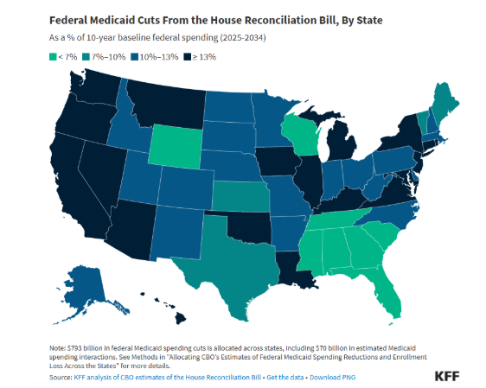

On May 22nd, the House of Representatives passed the One Big Beautiful Bill Act (H.R. 1) on a *close party-line vote of* 215-to-214.

This Republican-led legislation is now before the U.S. Senate and the National AFL-CIO with its affiliated Unions *are advocating against* the $1.3 trillion reduction in medical services that is included in the Republicans’ Budget Reconciliation Policy.

Based on assessments from Health Insurance Experts, Unions *are concerned* Working Families with employment-based coverage *may see their premiums increase significantly* *as a result of the uncompensated care costs expected to stem from this* legislation.

Health coverage *is a key benefit* Unions *often secure for their* Members through negotiation with employers.

Union-negotiated Health Benefits *are often provided through* a Multi-Employer Health Plan that is *jointly managed* by a Union and employers or under a Collective Bargaining Agreement with a *single* employer.

**The National AFL-CIO requested Industry Analysts advising these health plans to *provide an assessment of the impact of massive* Federal health spending cuts on people in employment-based coverage.**

Additional context is provided from other sources.

***Here are the key Concerns*:**

**Uncompensated care costs shifted to private insurance *could result in increased yearly costs of* $182-to-$485 *per person* for the 179 million people in employment-based coverage.**

***Hundreds of hospitals nationwide could reduce capacity or close due to lost* revenue, *making care unavailable in many* communities.**

**607,000 Health Care jobs *may be eliminated, intensifying* the U.S. health *staffing crisis* *and reducing everyone’s access to qualified* care.**

*If the Bills is eventually signed into law*, Industry Analysts say communities across the U.S. *will experience a financial shock that reduces everyone’s access to medical services.*

**The Republican Budget Reconciliation Bill *pairs a package of $3.7 trillion in tax cuts skewed toward the wealthy and corporations with massive spending cuts in* Medicaid, the Children’s Health Insurance Program (CHIP), the Affordable Care Act (ACA), and other Federal programs.**

**The Congressional Budget Office (CBO) found that the Republicans’ Reconciliation Policy *will eliminate $1.3 trillion* in health care spending under these programs, *through reductions in the Bill and failing to include* ACA *enhanced* premium tax credits among the scores of other tax provisions the Bill extends.**

**The CBO *estimated these combined policies will result in 16 million people becoming uninsured* *and* *many of the 16 million losing insurance will forgo needed* medical care, *even for chronic* conditions, *until they become seriously* ill.**

**To Continue Reading This National AFL-CIO Report, Go To:**[**Higher Costs and Less Care for Families With Job-Based Health Insurance | AFL-CIO**](https://aflcio.org/about/advocacy/legislative-alerts/higher-costs-and-less-care-families-job-based-health-insurance?fbclid=IwY2xjawK_ztNleHRuA2FlbQIxMABicmlkETFyakFCd0czaGxOaFEwd000AR7UjqiGkrz4ZlMPGmSHsmPslj2c3fFp-wl059L__eRyBcDsVOPb1U-HYXixcg_aem_ps-Z5EvQoHe88X-7tbuu8g)

**Graphic Provided By The National AFL-CIO**