AMERICAN FOUNDATION FOR SUICIDE PREVENTION
“PIERCE COUNTY WALK”, - SEPT 26, 2026 – CHAMBERS BAY TRAIL
Login

Fundraiser Search

Donate Now!
- Event Menu
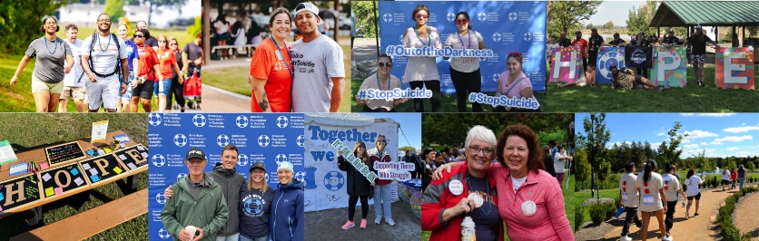
Pierce County Walk
Register Now!Donate To This Event
$0 RaisedGoal $50,000
2Participants
1Teams
0Donations Received
Event Date:
09/26/2026
Location:
Chambers Bay Park - Lower Lot, Tacoma, WA
Schedule:
Check In: 9:00 AM (PDT)
Event Start Time: 10:00 AM (PDT)
Contact:
Samantha Williams
206-643-5385
swilliams@afsp.org
  Why Walk?  Suicide is the 11th leading cause of death in the United States. To prevent suicide, we need to understand it first.  Funds raised at the Out of the Darkness Pierce County Walk directly support research, advocacy efforts, and educational programs in schools, workplaces, and communities across WA.  Register today and you're taking the first step to help save lives and bring hope to those affected by suicide. It's free, quick, and easy to make a real impact.  Click the Register Now button above to get started!  Having Trouble? |   About the 2026 Pierce County Walk  Sign up today to make sure you receive important updates about the Walk from the local organizers.  The Walks are an opportunity to find a supportive community of people who get it, to know you're not alone, and to make a difference together.  Walks are between 1 to 3 miles and non-competitive. The route and additional information specific to the Pierce County Walk will be added closer to Walk day.  Our program includes an opening ceremony, activities of hope and healing, resource tables, and complimentary honor beads for every participant.  Honor Beads

