Serving AA Groups in Area 72 District 43
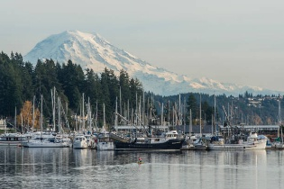
Gig Harbor
Tap addresses for Apple Maps
St John’s Episcopal Church
7701 Skansie Ave
Healthy Livers
Group Number 000109871
Sunday 6:00- 7:00 PM
Step in Time (Women’s)
Group Number 000079688
In-person
Sat: 9:00 AM
Men’s Stag Meeting
Sat: 9:00 AM
____________
Nick at Noon
4425 Burnham Dr
Group Number 000035927
Mon: Daily Reflections
Tuesday: 12 X 12
Wednesday: Daily Reflections
Thursday: As Bill Sees It
Friday Daily Reflections
____________

Harbor Life Church
4417 56th St NW
KISS Big Book Study
Group Number 000005631
Friday: 7:00 PM
Harbor Life Church
4417 56th St NW
From the Heart (Women’s)
Closed
Sat 10:00 AM
In-person & online
Zoom ID: 829 5585 6920
Password: 101479
____________

Miracle Tuesday
5500 Olympic Dr
Round Table Pizza
Tue: Noon
____________
Shoulder to Shoulder
Share & Speaker Interview Meeting
United Methodist Church
7400 Pioneer Way
Gig Harbor
Wed: 7-8:00 PM

Non-prayer AA meeting
Agnus Dei Lutheran Church
10511 Peacock Hill NW
Thur: 6:00 PM
*Group Conscious 1st Thurs of each month at 6:45 PM
“The only requirement for A.A. membership is a desire to stop drinking.”

Gateway Point
2609 Jahn Ave A-11
Serenity Hall
Sun-Sat: 7:00 AM
Sun-Sat: Noon
Sun-Sat: 5:30 PM
Sun: (Men’s) 8:30 AM
Mon: (Women’s) 10:00 AM
Tue: 7:00 PM
Wed: (Women’s) Noon
Thur: (Women’s) 7:00 PM
Sat: 8:00 PM
Recovery in Place
Women’s ONLINE
Mondays at Noon
freeconferencecall.com
Join Meeting/Access Code: 545866
Contact Mary Cooper
marycooper200@gmail.com

