Oakland's new push to stem homelessness: make RVs and tiny homes legal residences

[J.K. Dineen](https://www.sfchronicle.com/author/j-k-dineen/)

June 1, 2021Updated: June 1, 2021 1:27 p.m.

[Comments](https://www.sfchronicle.com/local/articleComments/Oakland-is-looking-to-make-RVs-and-tiny-homes-16211613.php)

3

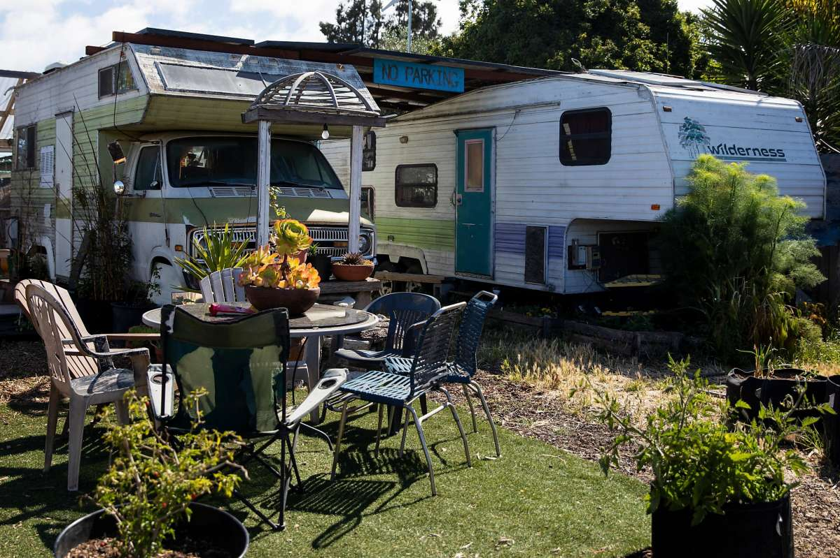1of3

The Neighborship is a co-operative village, where a handful of people are living in RVs in a communal setting, in West Oakland, Calif.

Jessica Christian/The Chronicle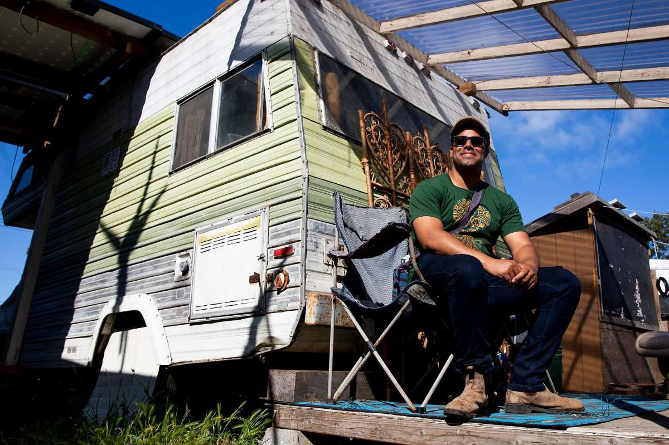

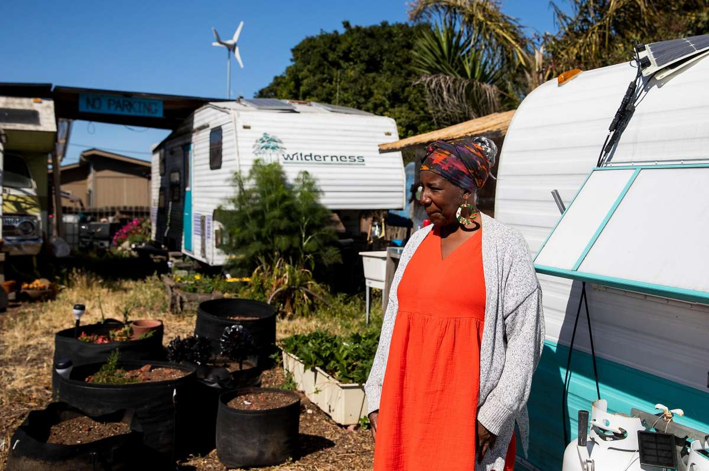

Recreational vehicles and tiny homes on wheels would become legal residences in Oakland under a wide-ranging set of proposed planning and building code changes meant to combat the city’s escalating housing costs and the explosion in the population of unhoused residents.

The set of Oakland ordinances, set to be announced Tuesday, would provide a “path to legalization” for a variety of housing types that are currently banned under city law but nevertheless have become prevalent in a city where the number of unhoused has jumped 47% from 2017 to 2019. At 940 per 100,000 residents. Oakland now has a slightly higher percentage of unhoused people than San Francisco or Berkeley.

The amended planning code would allow occupancy of recreational vehicles in all zoning districts where residential uses are permitted. It would apply only to tiny homes or RVs parked on private property, not on city streets or state-owned property like the parcels under freeways where encampments have proliferated in recent years, according to Darin Ranelletti, policy director for housing security under Oakland Mayor Libby Schaaf.

The ordinance would allow property owners to create tiny home or RV villages where they could charge enough rent to make it worthwhile while still offering housing at a deep discount compared with the $2,600-a-month average rent in Oakland.

The proposed changes come as construction costs in the Bay Area have risen 119% in the past decade — it now costs more than $600,000 to build a unit of housing. The costs are forcing cities like Oakland to get creative, Ranelletti said.

“We need new, lower-cost options for how we construct housing,” Ranelletti said. “It’s trying to get past a one-size-fits-all approach and allow flexibility and the kind of innovation Oakland is well-known for.”

Current zoning regulations prohibit mobile homes and manufactured homes unless they are installed on a permanent foundation.

While RVs and other vehicles would be legalized through the new rules, the city would still require that they comply with state and local habitability standards. They would have to be structurally sound and have heating and lighting, as well as 24-hour access to potable water and code-compliant toilet and bathing facilities under the occupants’ control. The bathrooms could be shared in a separate structure on the property.

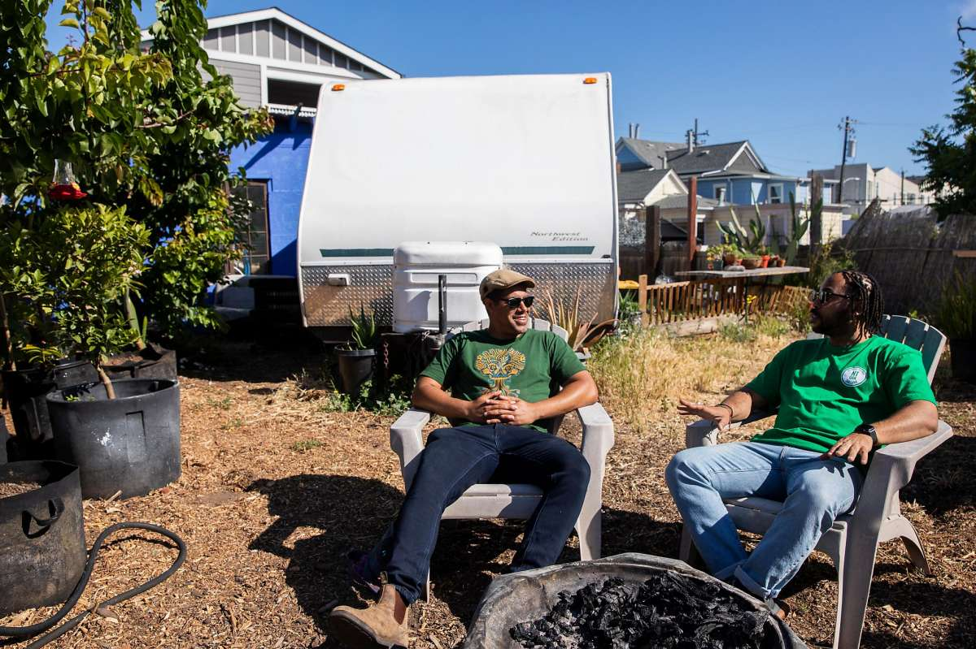

Neighborship co-operative village founder Adam Garrett-Clark (left) chats with Neighbors Together and Bottoms Up Garden founder Seneca Scott on the property where a handful of people are living in RVs in a communal setting on a lot in West Oakland.

Jessica Christian/The Chronicle

In addition to the changes around RVs and mobile homes, the ordinances would relax height limits for modular housing projects. Because modular projects stack factory-built boxes on top of one another, floors and ceilings are twice as thick as in conventional construction.