|  |  |
| --- | --- |
| A Reckoning in Boston | |
| Movie & Discussion | |
| About the film: Coming together at a night course at a community center, Kafi Dixon and Carl Chandler were seeking to transform their lives. When James Rutenbeck, a white suburban filmmaker comes to make a film about the school, he is forced to come to terms with his own complicity in racist structures in the community.  Kafi and Carl come on board as producers of the film and the three bring to light the history of systemic racism that has spanned generations, along with its modern implications. A RECKONING IN BOSTON shows that transformation, healing and social change begins within each of us. | |
|  |  |
| May 13th 14th & 15th  Free Streaming video  For access code for in-home screening contact  Rosemary Powers: rpowers@eou.edu  May 18th  6:30 – 8:30 pm.  In-person community conversation exploring implications for Tacoma/Pierce County  Local speakers and venue TBA. | |
|  |  |

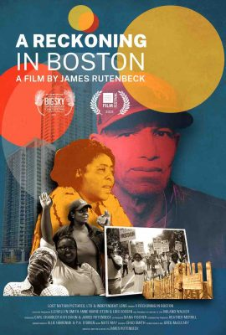

Event Co-sponsors

Tacoma Pierce County League of Women Voters,

A. Philip Randolpf Institute, Tacoma Chapter,

Tacoma Pierce County Coalition

to End Homelessness