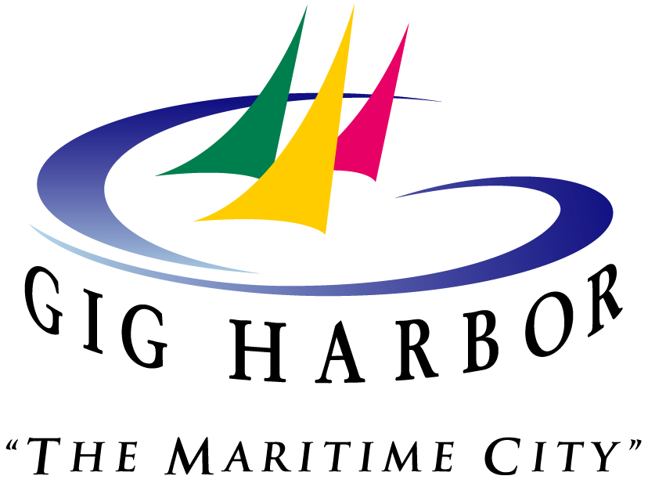

**Q&A on TRANSITIONAL HOUSING:**

**Q: Why did the City adopt codes specific to transitional housing and emergency shelters?**

**A:** The City had a deadline of September 30, 2021 to align with a new state law recently passed (ESSHB 1220) that requires all WA cities to allow transitional housing and emergency shelters. By passing an ordinance, the City Council adopted strict regulations pertaining to the uses.

**Q: Why did the state pass this law?**

A: This is a reaction to the attempts by some Washington cities to ban or severely restrict homeless shelters. The law forbids cities to prohibit indoor shelters in any zones where hotels are allowed, or to prohibit “transitional or permanent supportive housing” in residential areas.

**Q: Was this solely the decision of the Council and Mayor?**

**A:** No, this was an action Council deemed necessary in order to gain as much local control as possible over this statewide law.

**Q: Does this action now allow tent cities? Does it allow for homeless to sleep on public property or sidewalks?**

**A:** No, this ordinance does not allow for tent cities or for homeless to sleep or live on public property or sidewalks. Tent cities are a prohibited use within the City of Gig Harbor.

**Q: What additional standards is the City now adopting above the state guidelines?**

**A:** The regulations adopted by Ordinance 1466 now set separate standards for issues like spacing and overcrowding, adding in limits on the distance between shelters, the number of shelters allowed in the city at one time, and the occupancy limits of those shelters.

The City will allow only one continuously operating shelter at a time, and the occupancy limit is set at 10 families or 40 people, whichever is fewer. The City has now also set limits on “personal or supportive or transitional housing” in residential neighborhoods, requiring that dwellings be a minimum of a half-mile apart and follow the same basic building and safety codes as ordinary residential housing.

**Q: Does the City currently have an emergency shelter in place?**

**A:** No, and there are no currently proposed shelters.

**Q: Can Council continue to modify or adapt this ordinance in the future?**

**A:** Yes, these standards can be changed or modified through future ordinances or future Council votes. The City’s Planning Commission will further consider these regulations and make a recommendation to City Council regarding further restrictions. This recommendation is due by February 28, 2022.

**Q: What is the state definition of transitional housing?**

**A:** RCW 84.36.043: “A project that provides housing and supportive services to homeless persons or families for up to two years and that has as its purpose facilitating the movement of homeless persons and families into independent living. “

**Q: What is the state definition of emergency shelter?**

**A:** RCW 36.70A.030(9): “A facility that provides a temporary shelter for individuals or families who are currently homeless. Emergency shelter may not require occupants to enter into a lease or an occupancy agreement. Emergency shelter facilities may include day and warming centers that do not provide overnight accommodations.”

**Q: I would like to share my thoughts. How do I do that?**

**A:** Written public comment can be submitted to the City Clerk at 3510 Grandview Street, Gig Harbor, WA 98335, or by e-mail at cityclerk@gigharborwa.gov. All written comments must be received by noon on Monday, October 11, 2021. Written comments will be entered into the record for the Public Hearing but will not be read aloud during the public hearing.

All parties will have an opportunity to present oral comments at the public hearing by joining the virtual meeting at https://zoom.us/j/93216056382. The Public Hearing may also be accessed by calling (253) 215-8782 and entering Meeting ID 932 1605 6382.